The Effects of Lantana urticoides on Native, Desert Plant Species in a Dense, Jungle-Like Region

Abstract: The following research regards the effects of an invasive species, verbena
(Lantana urticoides), on native plant species in a natural region at El Camino Baptist Church in Tucson, Arizona. The information was gathered from August to November of 2015. Data from the past 18 years on temperature, weather, human disturbances, patterns of succession, and native species’ abundances and densities in the study plot was utilized to determine what factors largely affect the increase or decline of the most abundant, native plants. In addition, the 15m x 15m area under study was gridded out to discover the locations and quantity of the invasive species, with the overall purpose of finding out, having taken into account numerous other factors, what native plants were most affected by the verbena in particular. The results revealed that horseweed (Conyza canadensis) seemed to have been most drastically affected by the invader. The rest of the native species which have been most abundant in past years appear to have been primarily affected by human disturbances instead, as is evident in the large numbers of species fluctuations revolving around the establishment of man-made soil barriers.
Key words: Invasive species, native species, abundance, Lantana urticoides, verbena, temperature, precipitation, human disturbance, patterns of succession

Introduction:
Plant ecology is a topic that has drawn the attention of numerous individuals over the years; its primary purpose is to study the relationships between individual plant species. The overarching purpose in such research is to determine any harmful effects that may deplete native species in a given region, or provide benefits to invaders. Once such information is collected and interpreted, solutions may be found to reduce these damaging effects.
Over the years, students have dedicated their time to thorough research on numerous plant ecology topics at a study site located at the El Camino Baptist Church campus, situated on E. Speedway Blvd. in Tucson, Arizona. This particular report focuses primarily on how an invasive plant species, verbena (Lantana urticoides), affects the most abundant, native species in a given, measured out area of a plot. In order to conduct this study, conditions that affect both native and invasive species were resourced from previous years. By looking at this past research and determining what species thrive under which conditions, a system may be discovered in the future where any harmful effects on native plants by this invasive species can be reduced on a large scale.

Description of the El Camino Study Plot:

El Camino is a church campus. To the north of the buildings and rear parking lot
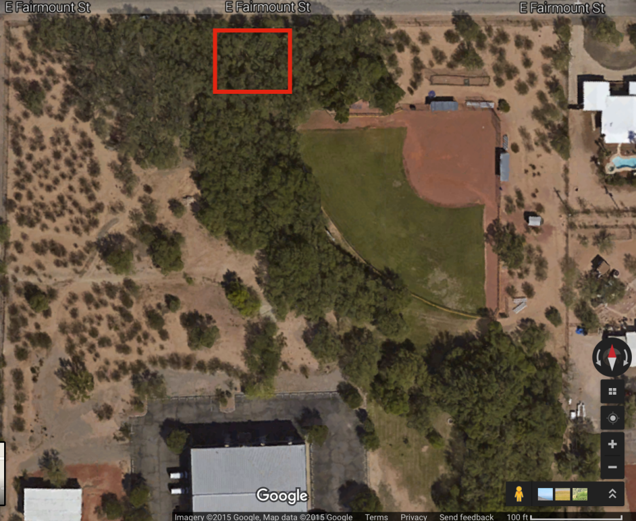
Fig. 1. Map showing the rear parking lot of El Camino Baptist Church and the natural study areas (both desert and jungle) to the north. The jungle study region is boxed in.

lies a piece of land heavily forested with various trees, bushes, and weeds. The land begins to resemble a desert as one heads west, since there is a creosote community, sandy soil, and more bare land. These forest and desert plots are bordered by a road on their northern and western sides. Humans occasionally tread through these natural pieces of land since a baseball field is situated at the northeast corner of the campus. In addition, the southernmost part of the desert community is disturbed (from bulldozing), while the northern part of the desert region is allowed to grow more naturally with less disturbance. The heavily forested area is occasionally bulldozed as well.
Though detailed information of these areas has been gathered over the years, this study only pertains to one particular spot known as the “jungle plot” (due to its species diversity and dense nature). The total size of the jungle study area is 15m x 15m; a fence runs alongside it on its northern border (of which on the other side is a road and neighborhood). Ragweed and verbena are the current, most abundant species, though there are numerous other plants such as mesquite, African sumac, milkweed, gray thorn, condalia, acacia, sacred datura, mistletoe, horseweed, desert broom, creeping vine, and pencil cholla. In addition, there is evidence of human interference. A great deal of maintenance is done in the surrounding area, as is seen through the recurring bulldozing (which occurs on an annual basis), and the setting up of a man-made soil barrier (this is placed in the jungle’s midst to prevent flooding in the neighboring residential area). As for precipitation, the study site receives, on average, 1.3 inches of rain per year. The average temperature ranges from the high 70’s to the mid 80’s degrees Fahrenheit (Natl. Weather Service Org.). Further, just down the road to the east of the campus lies a public storage unit. This site is heavily planted over with verbena.

History of the El Camino Study Plot:

The El Camino study site has been under observation since 1997. Over the course of 18 years, numerous species have dominated this piece of land. This particular space has also been under extreme influence by human disturbance from the bulldozing, and the introduction of verbena from the neighboring storage unit. The presence of the soil barrier (which has been up for the past five years) in the jungle plot itself has also had an enormous impact. This is not the first barrier, though; another was set up ten years ago to the east of the rear parking lot. It was formed in such a way that the water would drain northwest straight into the study plot. In addition, the invasive species was completely cut back two years ago, yet
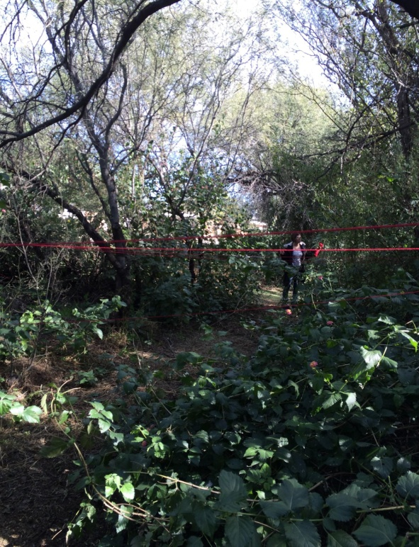
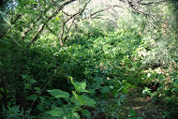
Fig. 2. Photograph of the dense jungle study plot.

appeared to be more dense when it reappeared the following year (Jim). The weather has also been inconsistent over the years of study; this impacts the plants in the area, including what thrives and what is now hardly existent.
Fig. 3. Photograph showing the mapping method using strings as a grid.

Methods:

The study was begun via a tour of the jungle plot. During this time period, the number of plants for each individual species was tallied; this procedure has been done by every research group in the past as well. Considering that four students made up this particular group, two pairs each counted the same plants so that an average number per species could be determined. In addition, information was provided regarding what kind of human interference takes place in this natural area.
This is the first time the jungle area has been mapped. The defined 15m x 15m plot was gridded out using yarn at intervals of 1m x 1m; this was threaded through the canopy of the plants. The number of each individual species was counted per square meter. When more than half a stem was in a particular 1m x 1m area, the plant was counted as being contained in that specific square. In addition, the locations of the

invasive species, Lantana urticoides, were plotted on a graph sheet of paper; two squares represented one meter (Goldberg and Turner 697-98). It was indicated on this graph sheet whether the plants were mature or juvenile. The overarching purpose of this was to determine the plant’s pattern of succession and abundance. Drought severity from past years of study was also examined using the Palmer Drought Severity Index (PDSI). The PDSI has a scale from -4 to +4, where -4 represents extreme drought, and +4 extreme moisture (699). In addition, a landscaper was interviewed at the plot in order to determine how quickly patterns of succession take place, and to find out since when the area has been barricaded in order to let water run through. Finally, all this data on the most abundant species per year, precipitation, temperature, and patterns of succession from past years was utilized and put together in order to find trends in what
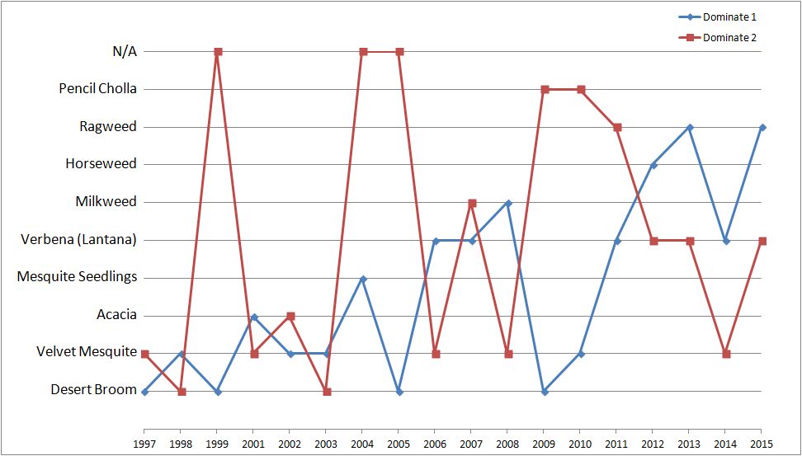
Fig. 4. Graph showing the most abundant species per year; blue represents the most common species, and red the second most common.

affects the native species in the jungle plot, along with reaching the overall goal of discovering to what extent Lantana urticoides affected the most common species over the years.
There were several sources of error that undoubtedly affected the data and conclusions drawn throughout the course of this study. For example, gridding the study plot resulted in mistakes in measurement. Each square was clearly not exactly one m² (at times the yarn was not threaded perfectly through a canopy, creating a slight zigzag pattern in some places), causing a problem when determining which species were located in which square of the grid. The mapping process was also never completed due to time constraints, the denseness of the jungle, and the fact that the verbena had all died (possibly frozen) by the time more data

was to be collected (the middle 5x15 meters were excluded). In addition, mistakes occurred in the number of plants that were
counted per m². For example, there were probably mistakes when tallying the number of species, and determining which plants were individuals. These errors would have affected the calculated density of each species. Not only would this have resulted in the presence of errors when trends were sought that compared the density of one species to the density of another species a different year, or when PDSI values for a certain time period were used to determine why the density was what it was, but it also would have caused over or underestimates of the severity of the abundance of the invasive species. An additional source of error included the fact that the study plot was bulldozed before it was mapped. Ultimately, this factor largely affected patterns of succession, since species were not allowed in such a circumstance to naturally reproduce and grow as they normally would. The man-made soil barrier also influenced these patterns, since plants were removed or cut back in the past in order to clear out a space for it. In addition to all these errors, there may have been mistakes on behalf of past classes in recording and transferring data to separate
sheets of paper.

Results and Discussion:

Effects of Weather, Temperature, Disturbances, and Patterns of Succession:

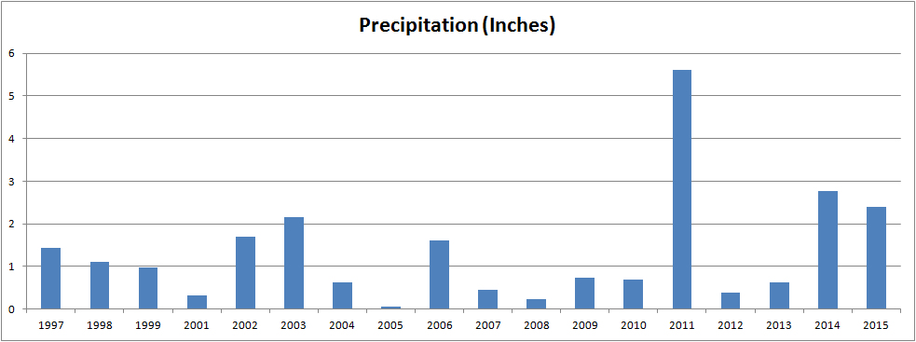
Horseweed (Conyza canadensis): Horseweed was the most abundant species in 2012. At the time, there were approximately 272.2 plants in the plot. This is equivalent to approximately 1.21 plants per m² (Advanced Biology 2012). The species prefers 14-55 inches of precipitation per year, and a temperature of at least 52 degrees Fahrenheit (“Conservation Plant”). While the average temperature over the past 15 years was 82.8 degrees (and thus suitable for the species), the precipitation had been at an average of about 1.5 inches during the previous five years (though in 2011 it was 5.6 inches) (Natl. Weather Service Org.). However, the fact that the soil barrier had been set up only two years before probably gave the plant sufficient moisture to grow and increase its density. This is further influenced by the fact that horseweed rapidly spreads in disturbed and wetland regions, and is highly competitive for water (Statewide Integrated). In addition, the plant can produce much seed, which swiftly spreads via wind (Tilley). An interesting trend that may be noticed is that in the two years prior to 2012, wind speed had increased from an average of 42 mph over the last 12 years to 69 and 66 mph in 2010 and 2011, and finally 59 mph in 2012 (Natl. Weather Service Org.). This increase may have additionally provided Conyza canadensis the opportunity to scatter its seed (though one must take into account that the area is highly dense, thus preventing wind from freely blowing through). The plant also grows quickly, which provides opportunity for the species to promptly establish itself (Statewide Integrated). All these factors likely contributed to horseweed’s abundance (even though the plant isn’t drought tolerant, and the PDSI value was between -2.00 and
Fig. 5. Precipitation for the month of September per year (inches).
-2.99 for 2012, which indicated moderate drought) (“Conservation Plant”; Hist. Palmer Drought). Horseweed further became most common the year after verbena was most abundant (Advanced Biology 2011-2012).
Milkweed (Sarcostemma cynanchoides): Milkweed was the second most abundant species in 2007, and continued spreading to become the most common plant the following year (Advanced Biology 2007-2008). It prefers well-drained, slightly moist soils, and part sun exposure (Almost Eden). However, milkweed also does well in a variety of conditions such as sandy washes, disturbed regions, and floodplains (DeLange). The species started increasing its cover in the jungle plot two years after the easternmost soil mound was set up, and three years before the soil barrier in the midst of the jungle area was established (Advanced Biology 2007-2008). A possible explanation for this is that the moisture content in the soil was too high for the milkweed once it started receiving collected water from both soil barriers. The level of sun exposure would have favored the plant’s growth as well since the region is dense, yet still penetrated by rays of sun. Further, the PDSI values in 2007 and 2008 indicated moderate drought and mid-range values (Hist. Palmer Drought). Unlike horseweed, milkweed is moderately drought resistant (Almost Eden). Sarcostemma cynanchoides also became the most common species the year after verbena was most abundant (Advanced Biology 2007-2008).
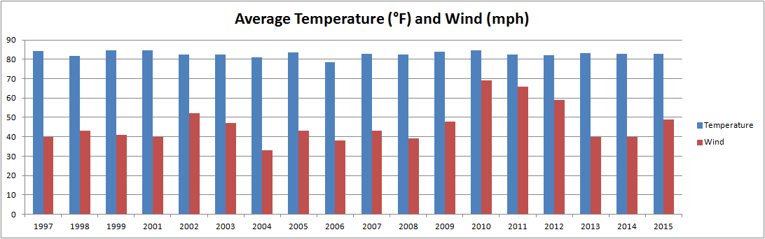
Desert Broom (Baccharis sarothroides): Desert broom grows extremely well in areas where the soil has been disturbed; this happens much in areas under construction. The plot is full of rubble composed of cinder blocks and different varieties of chopped wood. The species also grows faster than other native, desert plants. When there are many plants of Baccharis sarothroides, there is a lot less desert vegetation of other species ("Desert Broom"). In 1997, 1999, 2005, and 2009, desert broom was most common; in 1998 and 2003 it was second most abundant (Advanced Biology 1997-2015). The plant was additionally the most common species at PDSI levels of mid-range, moderate, and severe drought (Hist. Palmer Drought). As for precipitation, Baccharis sarothroides was most abundant during years receiving approximately 1.75 inches of rain. In addition, it was noted that the temperature was 84 degrees Fahrenheit when the species was the most abundant plant in 1997. The following year, the temperature dropped down to 81 degrees Fahrenheit, which may account for the fact that desert broom's numbers declined that year. This pattern is seen throughout the years; when the temperature was higher, desert broom became more abundant (Advanced Biology 1997-2015). Further, before the soil barriers were set up, Baccharis sarothroides was most common. Afterwards, its numbers decreased again with the exception of 2009 (Jim). Desert broom has not been most abundant since 2010 (when the mound was set up within the plot).
Fig. 6. Average temperature (°F) and average wind speed (mph) per year for the month of September. Temperature is blue, and wind is red.
Pencil Cholla (Cylindropuntia ramosissima): Pencil cholla has been in the jungle plot since 1997, when research first started to be conducted in the region. It was consistently among the top three most abundant species from 2003 until 2005, and then began to decline. In 2010 there were none left in the plot, though it returned the following year and weakly continued to increase until 2015 where there was only one (which was deeply hidden within the verbena). It thrives best in dry, rocky, sandy soil and flat or moderately sloping ground. The species prefers to grow in dense communities as well (Boone). There were approximately seven pencil cholla when the bulldozing outside the jungle plot (in order to create the soil mound) began in 2005-2006. The species increased in density over the next two years, and eventually started to decrease just before completely disappearing from the area. When the mound was formed inside the plot itself in 2010, the cholla was affected little and continued to remain small in number (Jim). As for precipitation, it is not completely clear how rain affected the cholla. There were approximately 0.66 inches of rain during the two years where it was the most abundant species, and the two years where it was the least common plant. In addition, the number of Cylindropuntia ramosissima increased when temperatures rose before the major disturbances began within the jungle plot. However, the number fluctuations were inconsistent after the disturbances. Wind also didn’t seem to affect the number of pencil cholla much in the study area. Overall, no weather patterns seem to largely influence this species’ abundances (Advanced Biology 1997-2015).
Ragweed (Ambrosia artemisiifolia): Ragweed is native to Canada and North America. It was nonexistent in the jungle plot until 2011 when it quickly became the second most abundant species; 58 plants were counted that year. The species disappeared the following year, and reappeared in 2013. In addition, there was a clear increase in 2015 in the number of plants (120 from the previous year to 5900). Ambrosia artemisiifolia prefers warm temperatures and moderate moisture. The temperature was approximately 82 degrees Fahrenheit during all the years where it was in the jungle plot. In addition, wind speed was 49 mph in 2015; this most likely had an effect on the spreading of the plants’ seeds. In addition, during the three years prior to the most abundant existence of ragweed, there were extremely high winds ranging from 59 to 69 mph. Further, the mound of soil established in 2010 also increased the amount of standing water in the plot, which could have been a factor as well in the plant’s increase. However, little can be determined considering the absence of ragweed’s presence in past years. Thus, not much can be explained regarding patterns of succession without much previous knowledge of its abundance (Advanced Biology 2011-2015).
Velvet Mesquite (Prosopis velutina): Velvet mesquite has been in the jungle plot since research started in 1997. It was most abundant in 1998, 2002, 2003, and 2010. The species tends to grow in dry grasslands (“Velvet Mesquite”). By the look of how old the mesquites are in the study area, it is quite possible that they were in the plot before all the other species took root. Additionally, in the 2000’s, the plant survived despite extreme heat, as is evident by the PDSI values for those years (Advanced Biology 1998-2010). In 2002 and 2003, the precipitation was approximately two inches; in previous years it was less than an inch. The tree roots, however, can extend up to 50 feet in length (15 meters). Thus, by digging deep the plant can draw the water and nutrients it needs to thrive (“Velvet Mesquite”). Therefore, it may be that once other native species established themselves, they took some of the water that the mesquite had been utilizing. This may also be why the plant went down in count after 1998. Furthermore, if Prosopis velutina was the most abundant species before the barrier was built, it could very well be that the plant received too much water in order to thrive after the mound was set up. Another interesting fact to note is that in 2010, the biggest mesquite grew on top of the newly built barrier; thus, the water that flowed through didn’t directly flood the tree (Jim).
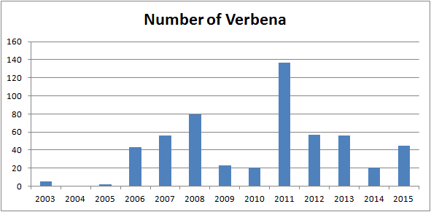
Verbena (Lantana urticoides): Verbena was the most abundant species in 2006, 2007, 2011, and 2014, and the second most abundant plant in 2012, 2013, and 2015. It is a large, flowering shrub native to Central and South America. The species thrives in warm environments with high rainfall, and typically grows in forests, making the jungle plot at El Camino the perfect place for the species to establish itself. Verbena forms dense thickets that tend to drive out native species, leading to complete dominance of the understory and canopy ("Lantana Fact Sheet"). In addition, a single plant can produce around 1,200 seeds per year (Martin). During the years prior to a spike in the number of Lantana urticoides, there was a higher wind speed which most likely spread a large amount of seeds (Advanced Biology 1997-2015). The PDSI values indicated mid-range, moderate, and severe drought during the years in which verbena was most abundant (Hist. Palmer Drought), and the temperature was usually around 82 degrees Fahrenheit as well. As for precipitation, there was a fairly small amount of rain each year where the plant was most abundant. The exception to this was in 2011 where there was a higher amount of rain. The following year, Lantana urticoides became the second most abundant species (Advanced Biology 1997-2015). Additionally, the soil mound outside the jungle plot was set up the year before verbena became most abundant in 2006. The water flowing down from the storage unit (where there are numerous verbena plants) would have been captured by that barrier and directed into the jungle plot, carrying along with it the invasive species’ seeds. Additionally, verbena was most common in the center of the plot where there was the
Fig. 7. The number of verbena plants per year.
most human disturbance.

Conclusions:

1) Horseweed originally seemed to outcompete verbena. The conditions favoring Conyza canadensis increased the native species’ numbers in 2012, resulting in Lantana urticoides’ inability to achieve the highest abundance (though the invasive species was second most abundant that year). However, during the next two years, horseweed completely disappeared. Those were the years where the invasive species was second most common, and then most abundant.
2) Milkweed was never able to outcompete verbena when the latter was the most common species. Lantana urticoides was most abundant the year before milkweed was second dominant, and continued to be the most common plant throughout the following year. However, the native plant became most abundant the following year when verbena wasn’t most common anymore. This, though, may merely be because of the effects that the soil barriers had on the species, demonstrating that Lantana urticoides probably didn’t have a very drastic influence on milkweed.
3) Verbena further appeared to have little effect on pencil cholla. Though there were massive fluctuations in the numbers of this native plant for years after the invasive species first spread to the jungle plot, there is no solid evidence that this was due to Lantana urticoides. These inconsistencies were most likely primarily due to human disturbances, and not the invasive species alone.
4) Ragweed was not shown to have been directly affected by the invasive species either. However, because this native species grows in primarily open spaces, it may very well be that its numbers will decrease if the verbena continues to spread, since the invader has already shown itself to quickly cover open areas (as is evident in the fact that it has surrounded the flatter regions around the study plot).
5) Velvet mesquite was most strongly affected by man-made disturbances; the church caused many vital effects by building barriers. This caused the plant to decrease in number, and probably allowed the invasive species to grow abundantly.
6) Verbena can withstand much more harsh conditions than native species in Arizona. This is probably the primary reason as to why it thrives in the study region. It has handled much water and severe droughts outside the plot as well. This is clearly evident since the invader was able to survive flooding when the soil mounds were built, unlike other plants such as desert broom and velvet mesquite which had more difficulty surviving because of how much water was filtered into the area.

Literature Cited:

Almost Eden. “Climbing Milkweed, Fringed
Twinevine.” Almost Eden. N.p., n.d.
Web. 11 Dec. 2015.
Boone, Jim. "Vegetation Around Las Vegas,
Pencil Cholla (Cylindropuntia
Ramosissima)." Vegetation Around Las
Vegas, Pencil Cholla (Cylindropuntia
Ramosissima). Birdandhike.com, Nov.-
Dec. 14. Web. 13 Dec. 2015.
"Conservation Plant Characteristics for
ScientificName (CommonName), USDA
PLANTS." Conservation Plant
Characteristics for ScientificName
(CommonName), USDA PLANTS.
USDA, n.d. Web. 11 Nov. 2015.
DeLange, George and Eve. “Arizona Wild
Flowers Pictures, Photos, Images,
Descriptions,
Information, Reviews.” The DeLange
Home Page. N.p., n.d. Web. 11 Dec.
2015.
"Desert Broom...Is It a Desert Plant or an
Noxious Weed?" Sonoran Oasis
Landscaping. N.p., 04 June 2012. Web.
13 Dec. 2015.
Desert Christian HS, Advanced Biology
various plant data, collected 1997-2015.
Goldberg, Deborah E., and Raymond M.
Turner. “Vegetation Change and Plant
Demography in Permanent Plots in the
Sonoran Desert.” Ecology 67.3 (1986):
695-712. Print.
"Historical Palmer Drought Indices." NCEI.
Nation Center for Environmental
Information, n.d. Web. 16 Nov. 2015. Jim. Personal Interview. 8 Dec. 2015.
"Lantana Fact Sheet." Lantana Fact Sheet.
N.p., 28 Oct. 2011. Web. 13 Dec. 2015. Martin, Jack. Desert Christian High School.
Advanced Biology, 10 Dec. 2015. National Weather Service Organization.
“Monthly Climate Reports and F-6 Data
for Tucson AZ.” National Weather
Service Forecast Office. National Oceanic
and Atmospheric Administration, n.d.
Web. 19 Nov. 2015.
Statewide Integrated Pest Management
Program. “Horseweed (Conyza
canadensis).” University of California
Agriculture & Natural Resources.
University of California, n.d. Web. 11
Dec. 2015.
Tilley, Derek. “Ecology and Management of
Canadian Horseweed (Conyza
Canadensis).” Natural Resources
Conservation Service. United States
Department of Agriculture, Dec. 2012.
Web. 11 Dec. 2015.
"Velvet Mesquite - Prosopis Velutina."
Velvet Mesquite - Prosopis Velutina.
N.p., 2002. Web. 13 Dec. 2015.

