RNR 230L – Field Botany
Field Trip #1: Santa Catalina Mountains

- Plant Descriptions at Middle Bear Campground

The varying species of plants that grow at Middle Bear Campground include oak (such as the Mexican blue oak), Arizona grape ivy, Chihuahuan pine, alligator juniper, and ponderosa pine.

Species: | Characteristics:
Mexican Blue Oak | Oaks are forest species that are mostly evergreen (this is true of six of the seven species) and grow scattered across the landscape. They typically flower late in the year (in April).
Arizona Grape Ivy | The Arizona grape ivy is a deciduous plant that typically grows in riparian and shady areas. Its grapes have a dark green to light purple hue.
Chihuahuan Pine | The cones of a Chihuahuan pine hang on the tree for around five years, and are a chestnut brown color. The seeds are difficult for wildlife to access. The pine itself is the dominant pine in Chihuahua (Mexico contains a high diversity of pines).
Alligator Juniper | The alligator juniper produces seed cones in the spring. In addition, its roots are rather aggressive in that it usually outcompetes other plants. It has scaled, alternating leaves and small, fleshy, round cones. Its bark resembles an alligator’s skin.
Ponderosa Pine | This pine’s needles are around 17.8 to 20 cm long. It contains four to five needles per fascicle, and the bark in a mature individual is reddish to light brown. It is of great value to the wildlife around, and is also fire-dependent to thrive (otherwise there would be too many seedlings).

- Stride Length (Note: 1 stride is equivalent to two steps)
  - Three 20 m segments:
    - Average number of strides:

The three trials turned out to be 12.5, 12.5, and 12.25 strides.
12.5 + 12.5 + 12.25 = 37.25
37.25/3 = 12.4
Thus, the average number of strides was 12.4.

    - Average length per stride:

20 m / 12.42 strides = 1.6 m

  - Explain why knowledge of stride length is a useful tool in field botany:

Knowing one’s stride length is a useful tool in that it eliminates the need for a measuring tape when trying to determine general distances. For example, if one is aware of approximately how many strides they must walk to go 20 m, they can count their strides instead of constantly having to lay down a measuring tape.

- Forest Mensuration Procedures (Note: the added/subtracted numbers within the parentheses for each calculation correspond with the values obtained from a clinometer, a device used to estimate tree height. See the diagrams, obtained from my botany class’s lab manual, below for more information.)

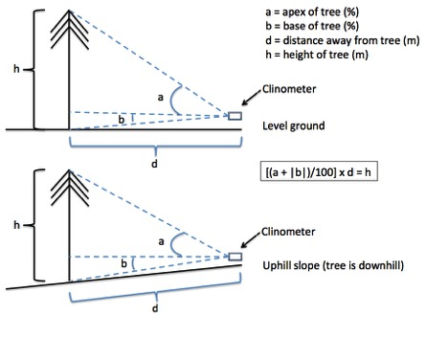

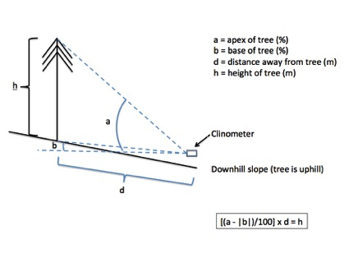

  - Tree height:
    - A: Alligator Juniper (Juniperus deppeana)
Height:
A: (75.3 + 8)/100 x 20 = 16.7 m

    - B: Ponderosa Pine (Pinus ponderosa)
Height:
B: (141.7 + 11)/100 x 20 = 30.5 m

    - C: Chihuahuan Pine (Pinus leiophylla)
Height:
C: (78 – 2.3)/100 x 20 = 15.1 m

  - Diameter at breast height (DBH):

Each member in the group determined where “breast height” (1.37 m) was on their body. Then, two people stood on opposite sides of the trunk. Holding the measuring device diameter side up, the tape was wrapped around the trunk in correspondence with breast height for each individual on each side of the trunk.

    - A: 43 cm
    - B: 77.5 cm
    - C: 35 cm

Tree: | Apex of Tree: | Base of Tree: | DBH:
A | Values: 71, 75, 80  Average: 75.3 | Values: 7, 7, 10  Average: 8 | 43  cm
B | Values: 150, 130, 145  Average: 141.7 | Values: 10, 10, 13  Average: 11 | 77.5 cm
C | Values: 78, 78, 78  Average: 78 | Values: 6, 0, 1  Average: 2.3 | 35  cm

- Plant Identification at Aspen Viewpoint
  - Identifying an aspen:

An aspen may be identified via its white bark and leaves which typically flutter in the wind. In addition, it can commonly be seen in the mountains, and is naturally dioecious, providing one with another useful identification tool. Further, during the fall, the trees’ leaves take on beautiful yellow and red tones.

  - Aspen Fire aftereffects:

The Aspen Fire resulted in the burning of many latter fuels; it destroyed seedbanks and hit the canopies of trees as well, not just their bases. However, because it primarily moved uphill, the aspen trees further down in the valleys were not quite affected as much. In addition, since aspens are not as prone to burning as other trees (such as conifers), they were not as negatively impacted as other species.

- Plant Identification at Bear Wallow

The varying species of plants that grow at Bear Wallow include spruce, southwestern white pine, large Douglas fir, boxelder, and bigtooth maple.

Species: | Characteristics:
Spruce | Spruce trees have no fascicles. The cones have double-layer scales, and are somewhat flexible. They grow on mid-high elevation sites.
Southwestern White Pine | The cones of this tree are bent back at the tips. There are around five needles in every fascicle; the needles themselves are blue-green. Small mammals are drawn to the seeds within the cones.
Large Douglas Fir | This tree is evergreen, and has thick, cork-like bark. The cones have visible bracts, and are 7.6 to 10 cm long. The needles are spirally arranged and are around 2.5 cm long.
Boxelder | This tree’s leaves change color in the winter. It is deciduous, and has light gray bark. The leaves are divided as well with around three leaflets (5-10 cm long) that have a light green hue. They may also be partially lobed.
Bigtooth Maple | The bark of this tree is gray-brown and slightly furrowed. The plant is deciduous, and has leaves (5-12.7 cm) that are palmately (three to five) lobed.

- Stride Length on Slopes
  - 20 m segment:
    - Uphill: 16.5 strides
Length per stride: 20 m / 16.5 strides = 1.2 m

    - Downhill: 21.5 strides
Length per stride: 20 m / 21.5 strides = 0.9 m

  - Compare the varying values:

The lengths per stride on an uphill and downhill slope were both shorter than those on flat ground. This is useful information in field botany because it helps one to take into account the uneven terrain when trying to determine how many strides one needs to take away from a plant in order to achieve a desired distance.

- Site Descriptions
  - Douglas Fir:

Pima Co., AZ. Mt. Lemmon Hwy. Turn east onto E. Upper Bear Wallow Rd. Follow this road for 708 m (three large rocks may be visible on the east side of the road at this distance). Head 44.8 m NW (310°) (a campfire may be found at this distance). Head 59.2 m NW (0°). Latitude: 32.419556° N, Longitude: 110.731514° W. Elevation: 2426 m a.s.l. (Lat., long., and elev. estimates based on analysis of Google Earth image, 13 September 2016).

  - Member of the Asteraceae with yellow flowers:

Pima Co., AZ. Mt. Lemmon Hwy. Turn east onto E. Upper Bear Wallow Rd. Follow this road for 708 m (three large rocks may be visible on the east side of the road at this distance). Head 27.2 m NW (310°). Plant is located exactly N (0°) of the trail. Latitude: 32.419092° N, Longitude: 110.730886° W. Elevation: 2421 m a.s.l. (Lat., long., and elev. estimates based on analysis of Google Earth image, 13 September 2016).

- Plant Density
  - Describe the method you used to estimate plant density. Provide a diagram:

A tree of the desired species (southwestern white pine) was identified. Next, four people walked 20 m away from the tree (each in a different direction at 90 degree angles, forming a square). Another individual then counted how many trees of that same species could be identified on each 20 m transect (this included trees that were one m off the transect line). The trees of the desired species within this 40 by 40 m square were added up. A second trial was done, and the average was determined. Next, a calculation was taken of how many trees there were per m². Finally, m² were converted to hectares by multiplying the obtained value by 10000 (since there are 10000 m² in a hectare).

20m
|
|
20m - - - Center Tree - - - 20m
|
|
20m
  - Estimate plant density:

The first count was 47 plants per 1600 m², and the second was 16 plants per 1600 m².

(47 + 16)/2 = 32 plants per 1600 m² (average)

32/1600 m² = 0.02 plants/m²

0.02 plants/m² x 10000 m² = 200 southwestern white pines per hectare

