Duration of Fall and Winter Flowering and Fruiting Phenophases in Carnegiea gigantea in Response to Temperature and Precipitation

Sandy Slovikosky

Introduction:

Saguaro (Carnegiea gigantea) are one of the symbolic species of the Sonoran Desert. One of the primary ways they have been studied is with regard to phenology. While the plants’ typical flowering and fruiting phenophases are from May to June, Drezner (2014) notes that winter precipitation can stimulate these cycles as well at above freezing temperatures (p. 587). The question being tested, consequently, was whether the durations of fall and winter flowering and fruiting phenophases in the saguaro of the Joseph Wood Krutch Garden in Tucson, Arizona became shorter, longer, or remained relatively the same over the past four years in response to various temperatures and precipitation. The hypothesis was that the cycles would show a trend in which they gradually grow longer and span an increased length of time. Resultant predictions indicated the first “yeses” of the flowering and fruiting phenophases should occur earlier as the years progressed, the annual last “yeses” should occur later, or a combination of the two would be evident.

Methods:

In order to determine the duration of the phenophases, data was utilized from the National Phenology Network’s database from August to December for 2013 to 2016. In August, the first date on which a flower bud was seen was recorded, as well as the latest date at which an open flower was present up through December. For fruits, the first instance of a fruit was recorded in addition to the last day on which recent fruit or seed drop was seen. The two dates were then subtracted from one another to obtain a duration in days, end date included. For temperature, the average, monthly value in Celsius was taken from The Arizona Meteorological Network, whereas precipitation in centimeters was added up per month. These data were also recorded for August to December.

Results:

The table (Fig. 1) indicates that duration of the fruiting phenophase showed a general increase, whereas flowering demonstrated more fluctuations in pattern. This can also be visually observed from the graph (Fig. 2) where the fruiting bars indicate a general trend upward and the flowering ones display a pyramidal pattern. Nonetheless, given the poor amount of data in 2016 for the flowering phenophase, only the first three blue bars should be taken into consideration. Moreover, while flowering started at relatively the same time period in 2013 and 2014, it jumped to three weeks earlier in 2015. The last date of flowering showed a three week increase between 2013 and 2014 and then dropped back down to a month earlier in 2015. As for fruiting, the first date started a month earlier between 2013 and 2014 and was again pushed back by two weeks in 2015. The last date of fruiting occurred less than three weeks later between 2013 and 2014, remained relatively constant in 2015, and then was pushed back again by approximately two weeks in 2016.
Fig. 1: First Date, Last Date, and Duration in Days for Flowering and Fruiting Phenophases of Carnegiea gigantea per Year
 | Flowering Phenophase |  |  | Fruiting Phenophase
 | First Date | Last Date | Duration (Days) | First Date | Last Date | Duration (Days)
2013 | September 20 | November 6 | 48 | October 10 | November 20 | 42
2014 | September 19 | November 27 | 70 | September 12 | December 8 | 88
2015 | August 31 | October 20 | 51 | August 31 | December 3 | 95
2016 | September 9 | September 14 | 6* | August 30 | November 21 | 84
*Limited data available
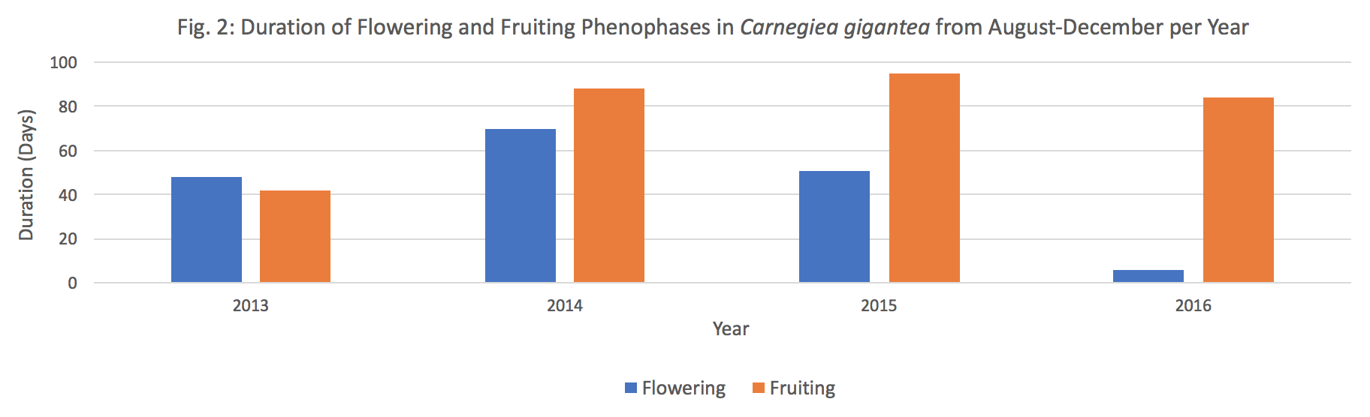

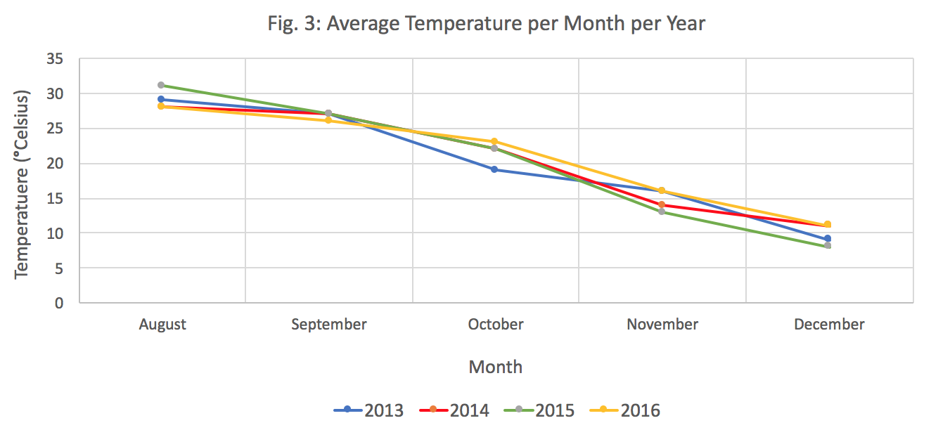

Note: Numerical data obtained from The Arizona Meteorological Network
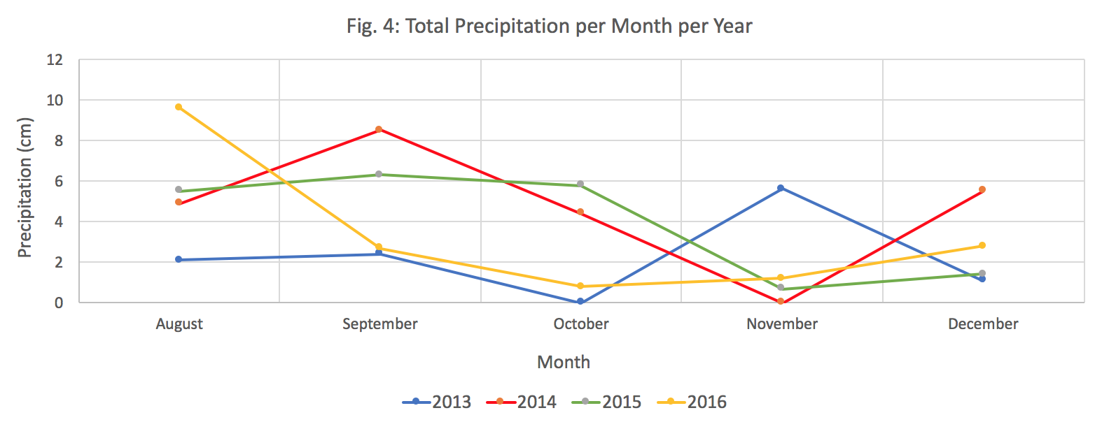

Note: Numerical data obtained from The Arizona Meteorological Network

Discussion:

The earlier date at which the flowering and fruiting phenophases occurred between 2014 and 2015 may partially be attributed to the warmer August temperatures in 2015 (Fig. 3), especially when considering precipitation was similar between the two years for this month (Fig. 4). The push back in fruiting for the first day between 2013 and 2014 could be due to increased precipitation; August and September both saw more rainfall in 2014. As for the last dates, the later occurrence of a flower and fruit between 2013 and 2014 was unexpected given both the warmer temperatures and higher rainfall in 2013 than 2014 for November. This holds true as well when comparing the final dates of the flowering phenophase between 2014 and 2015; October of the latter year had more precipitation, raising questions as to why the last day thus occurred earlier than in the former. Finally, the earlier last fruiting day in 2016 as opposed to 2015 was odd given that both precipitation and temperature were higher in November 2016. These results partially supported the predictions as most of the first dates grew earlier, though several of the last dates didn’t gradually occur later.

According to Bowers (1996), saguaro may use water stored within their tissues to produce flowers even when rainfall is limiting (p. 69). Moreover, the author states that warmer temperatures, together with at least 5 to 9 mm of rain, stimulate these phenophases (p. 69). Such findings may help explain the outcomes of this fall and winter study apart from the typical growing season. The biggest limitation to this research, though, was the small amount of data available; it would be more practical to repeat it several decades from now with a larger set of observations. Finally, a possible follow-up study would be to compare these results to the phenophases of other cacti to see if there are similar responses to environmental conditions.

References:

Bowers, J.E. (1996). Environmental determinants of flowering date in the columnar cactus
Carnegiea gigantea in the northern Sonoran Desert. Madroño, 43(1), 69-84.

Drezner, T.D. (2014). The keystone saguaro (Carnegiea gigantea, Cactaceae): a review
of its ecology, associations, reproduction, limits, and demographics. Plant Ecology, 215(6), 581-595.

Tucson Station Data and Reports. The Arizona Meteorological Network. Retrieved from https://
cals.arizona.edu/azmet/01.htm

