- Sandy Slovikosky
- List
  - Canyon treefrog – N
  - Red-spotted toad – N
  - Nightsnake – N
  - Black-necked gartersnake – N
  - Gophersnake – N
  - Long-nosed snake – N
  - Kingsnake – N
  - Western patch-nosed snake – N
  - Sonoran spotted whiptail – N
  - Tiger whiptail – N
  - Zebra-tailed lizard – N
  - Greater earless lizard – N
  - Clark’s spiny lizard – N
  - Desert spiny lizard – N
  - Ornate tree lizard – N
  - Side-blotched lizard – N
  - American bullfrog – I
  - Pond slider – I
  - Mediterranean house gecko - I
- 16 native
- 3 introduced

Anurans (2):
1. Canyon treefrog – Hyla arenicolor
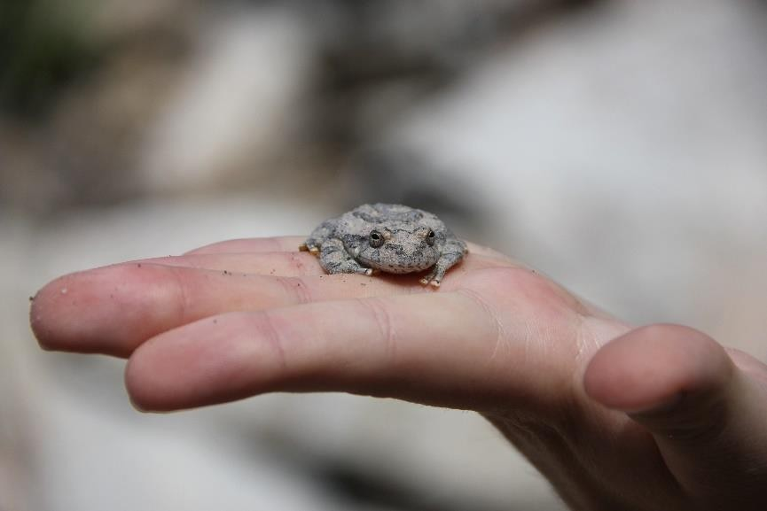

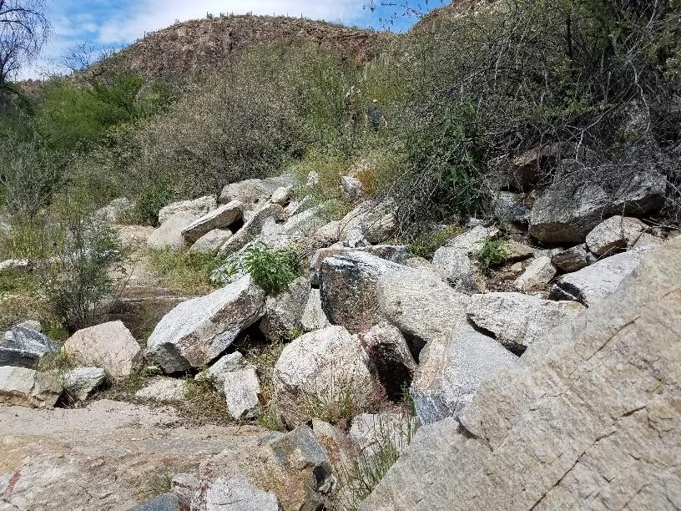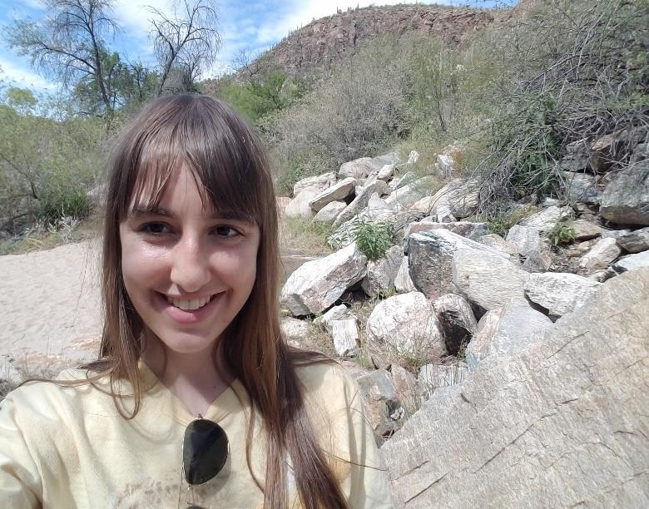

Date: April 18, 2020
Time: 10:47
Habitat type: sitting on rock located 10 m north from water’s edge, vicinity is Arizona upland Sonoran desertscrub
Specific location: 32°19.4123’N, 110°48.4688’W, Sabino Canyon, 2 km from visitor center following N. Sabino Canyon Rd., 13 m south of road

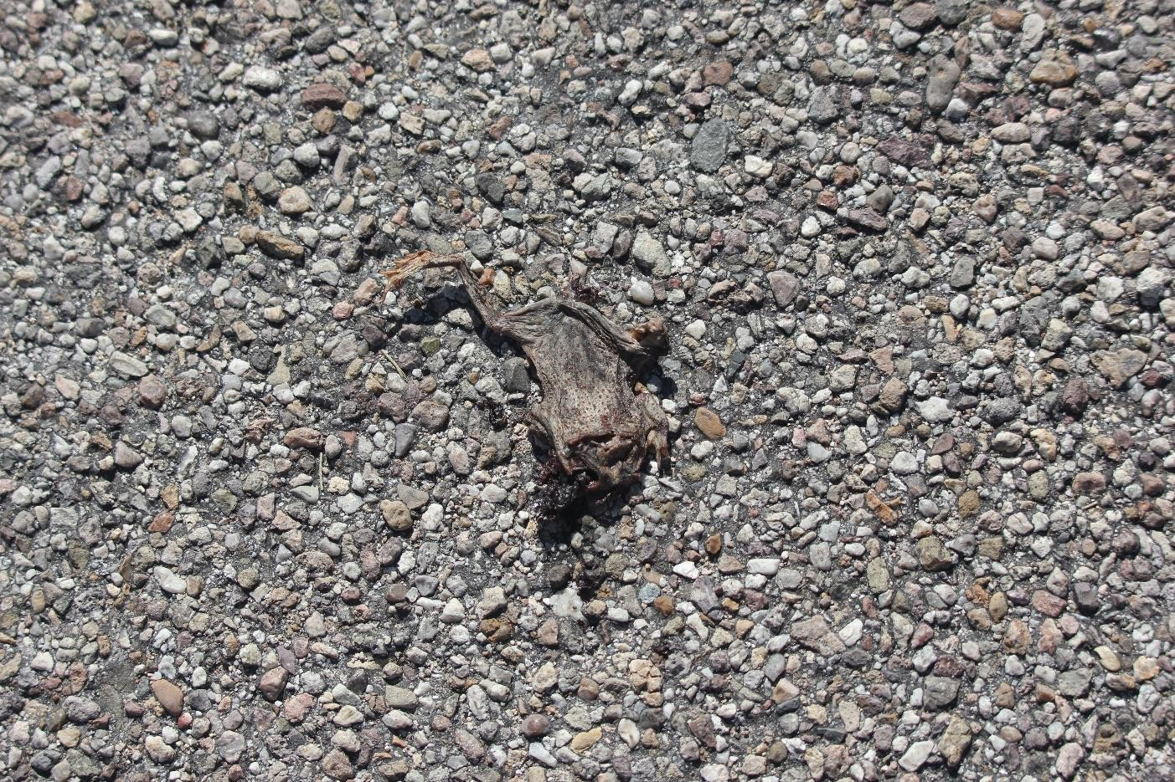
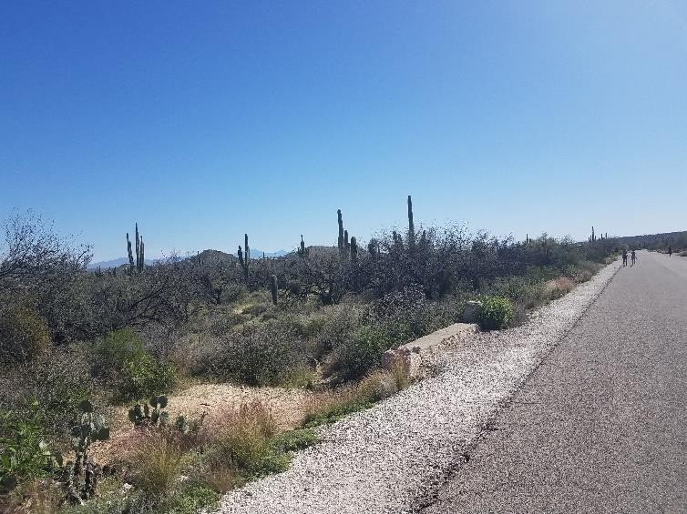
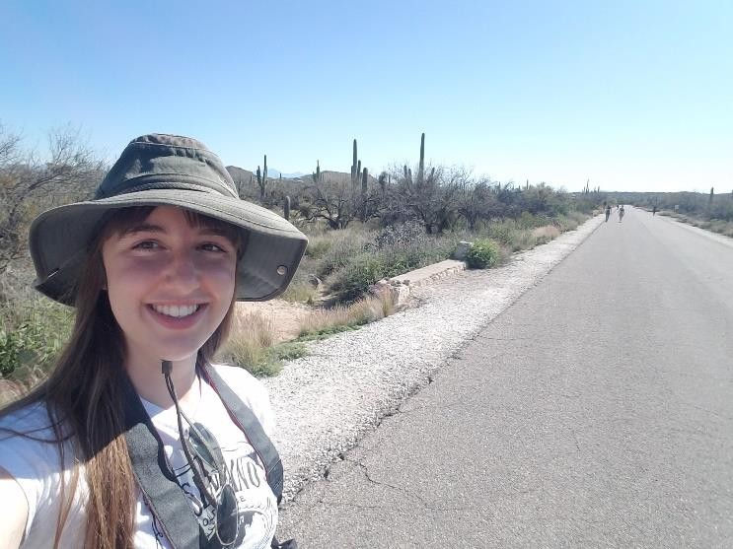

Date: April 4, 2020
Time: 13:28
Habitat type: squashed on road, vicinity is Arizona upland Sonoran desertscrub
Specific location: 32°18.8144’N, 110°49.1667’W, Sabino Canyon, 465 m from visitor center following N. Sabino Canyon Rd.

Squamata (snakes - 6):
3. Nightsnake - Hypsiglena torquata
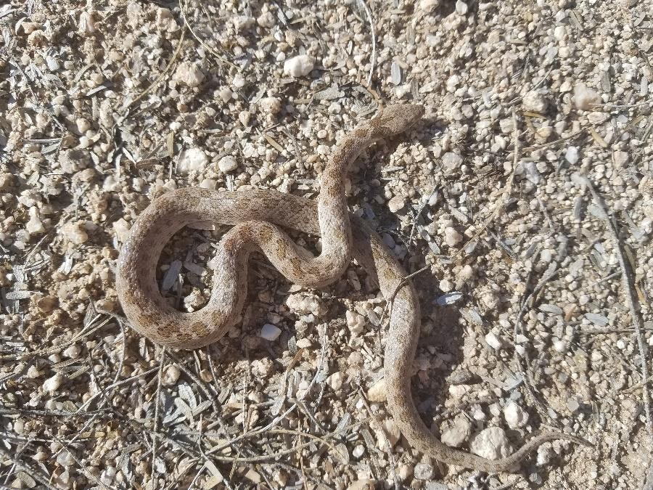
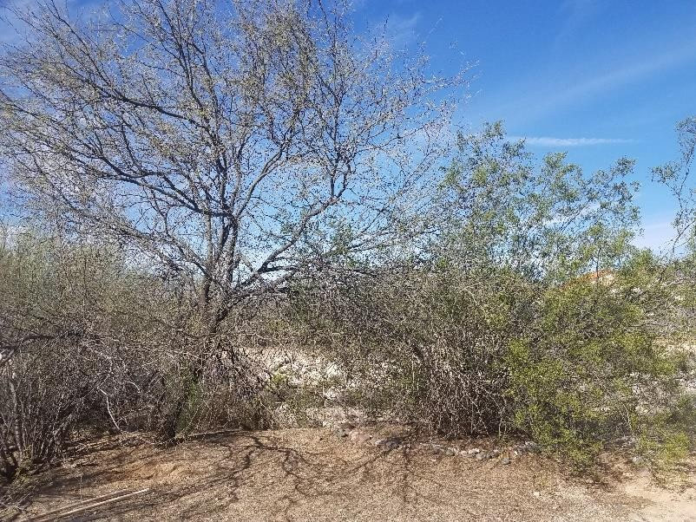
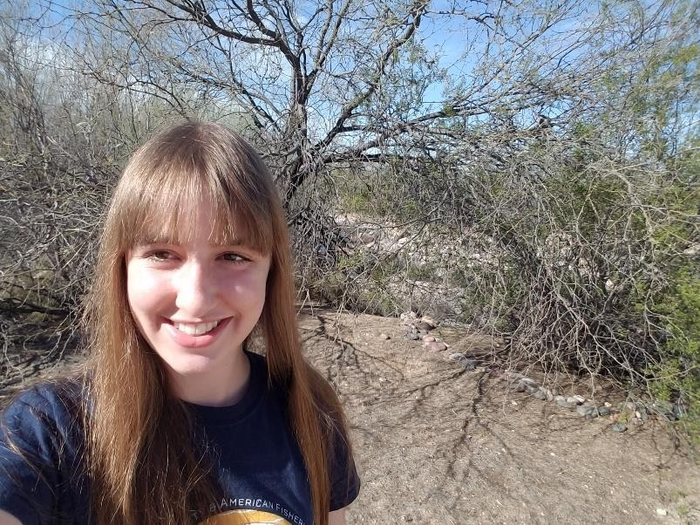

Date: March 23, 2020
Time: 9:10
Habitat type: discovered in garbage bin in the morning (fell in overnight), released on patch of bare ground with surrounding creosote bush and mesquite shrub near wash in Arizona upland Sonoran desertscrub suburban area
Specific location: ...

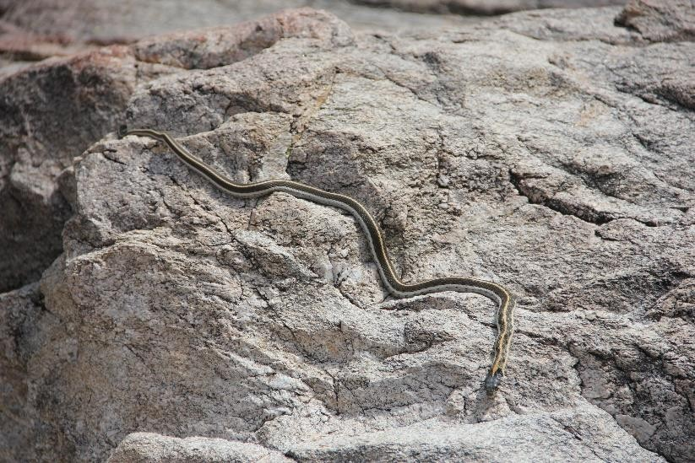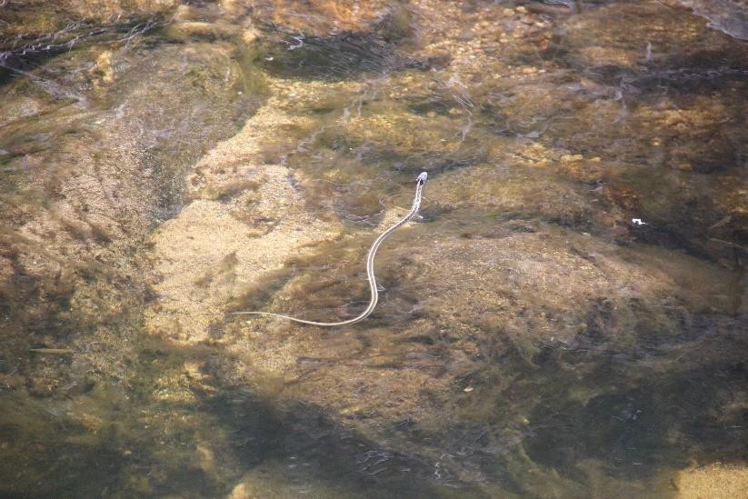

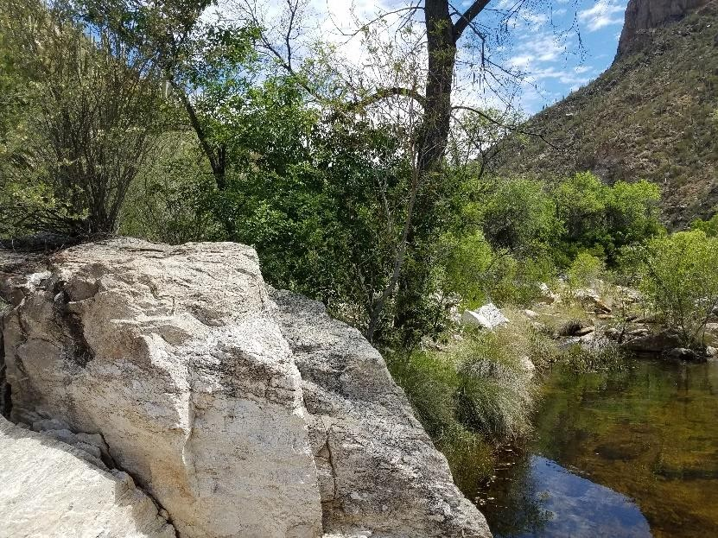
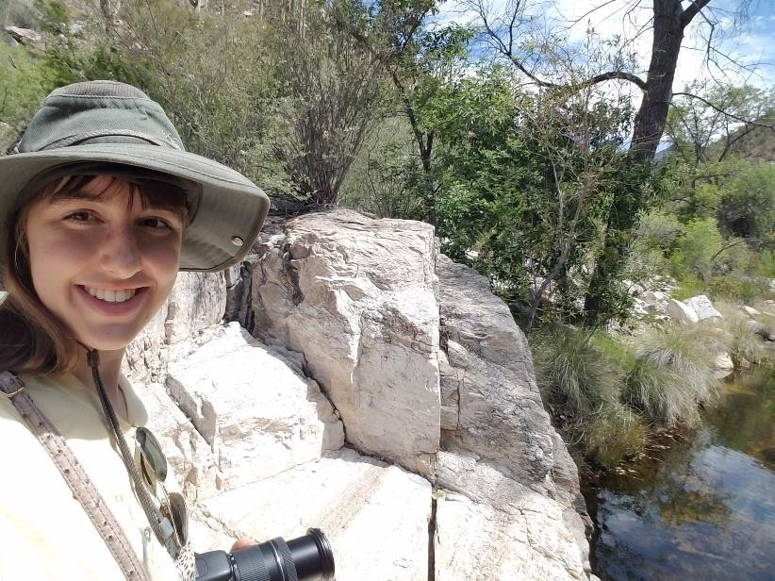

Date: April 18, 2020
Time: 10:52
Habitat type: slithering on rock located 3 m from water’s edge, vicinity is Arizona upland Sonoran desertscrub
Specific location: 32°19.4123’N, 110°48.4688’W, Sabino Canyon, 2 km from visitor center following N. Sabino Canyon Rd., 20 m south of road

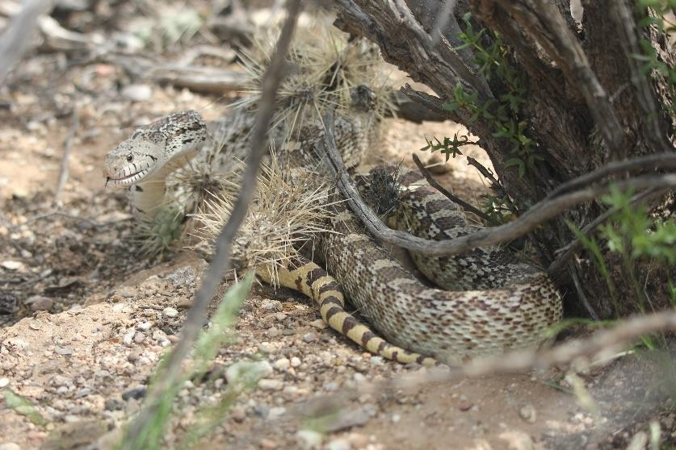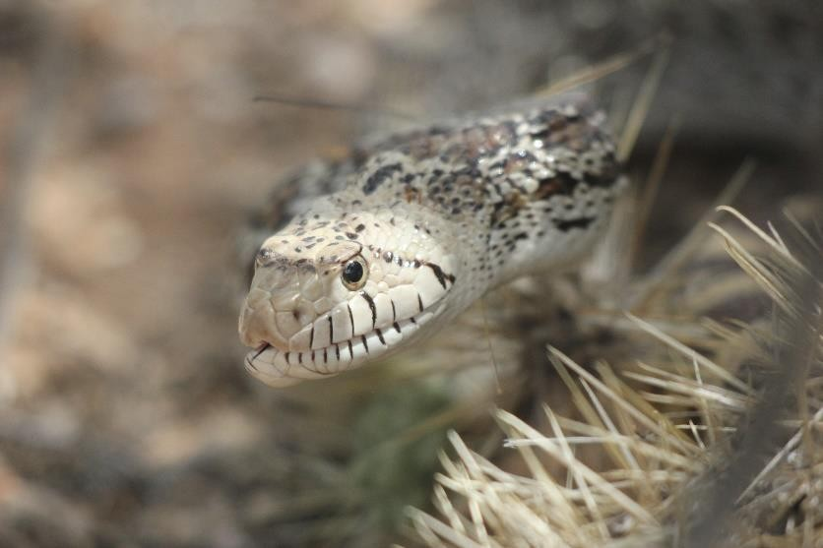
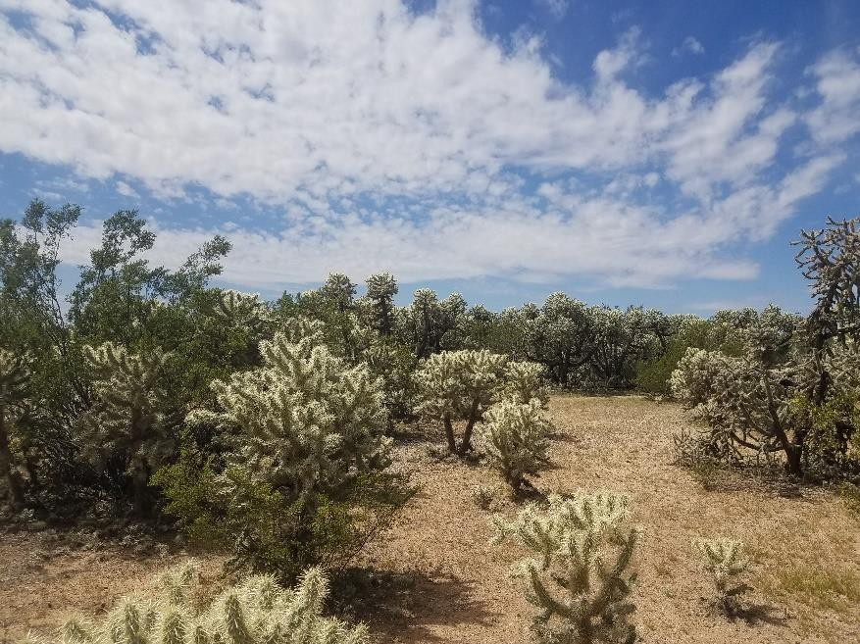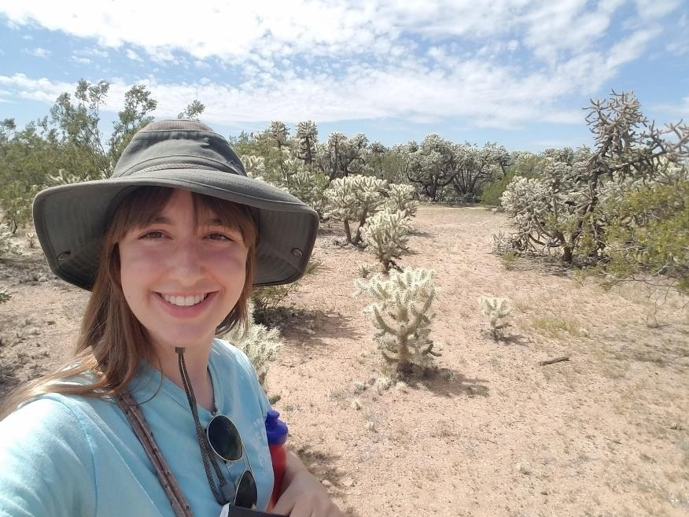

Date: April 1, 2020
Time: 11:29
Habitat type: slithering between cholla plants in Arizona upland Sonoran desertscrub
Specific location: 32°14.8324’N, 110°50.1206’W, Udall Park, 503 m into park from west entrance on N. Sabino Canyon Rd., then 25 m south of road

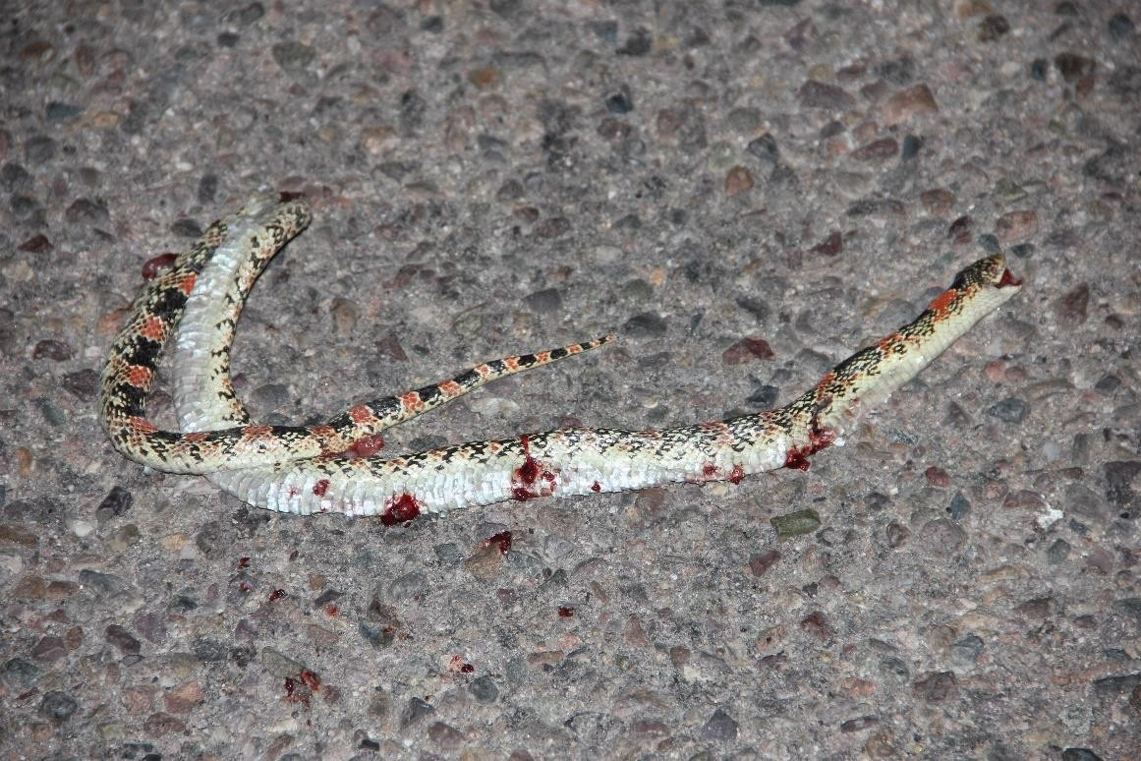
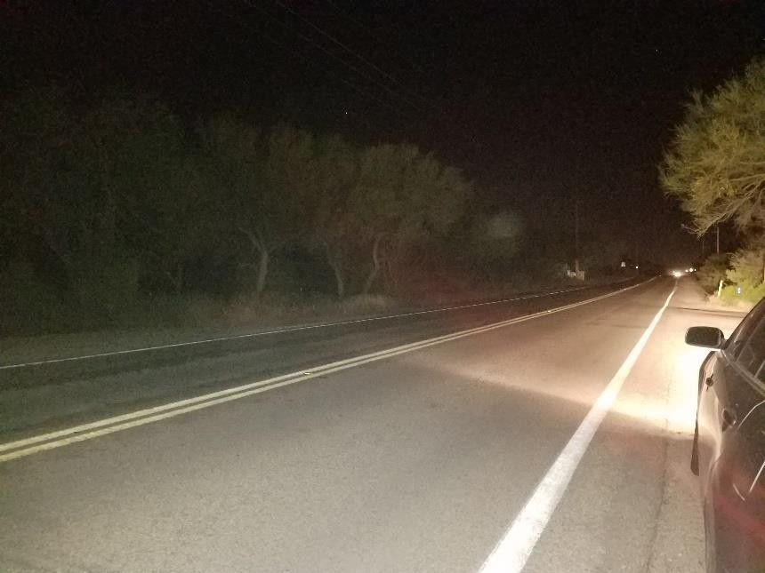
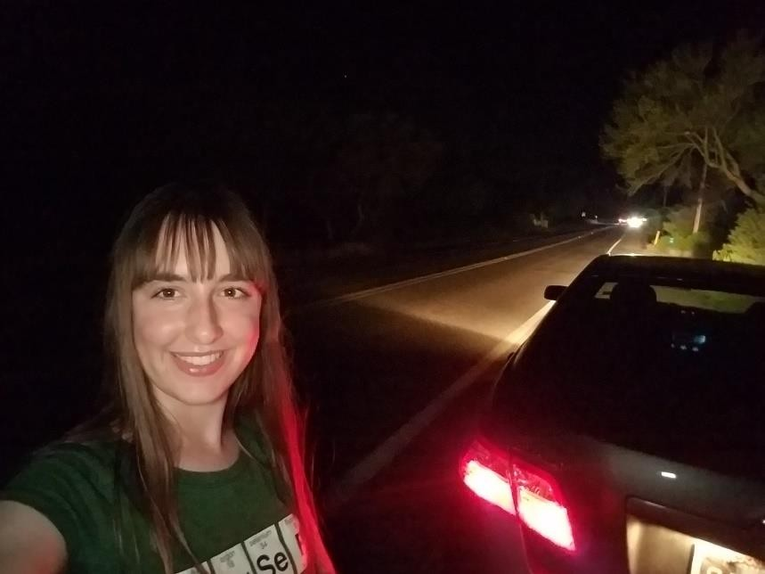
Date: April 25, 2020
Time: 22:13
Habitat type: squashed on road, vicinity is Arizona upland Sonoran desertscrub
Specific location: 32°15.0496’N, 110°42.3692’W, 1.4 km east of intersection of N. Wentworth Rd. and E. Redington Rd.

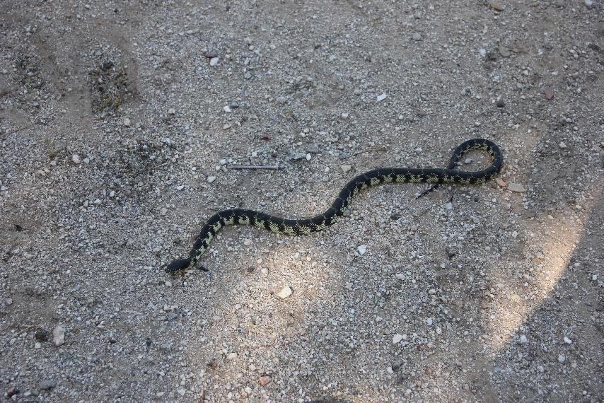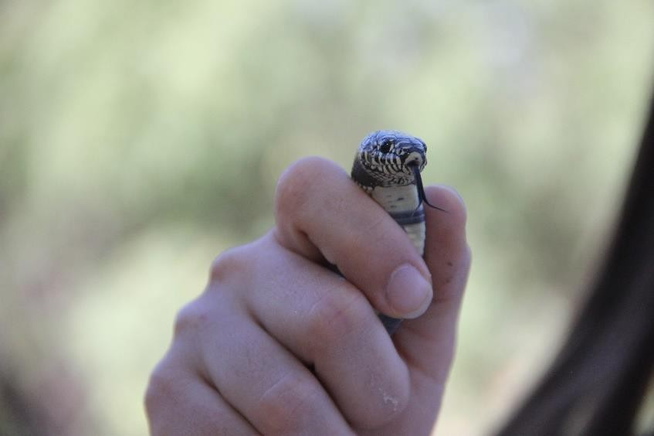
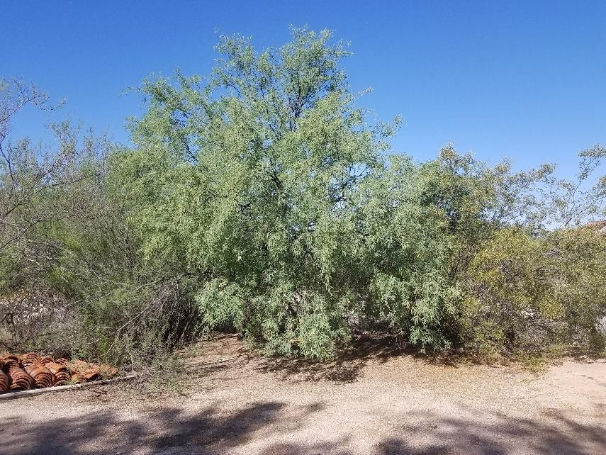
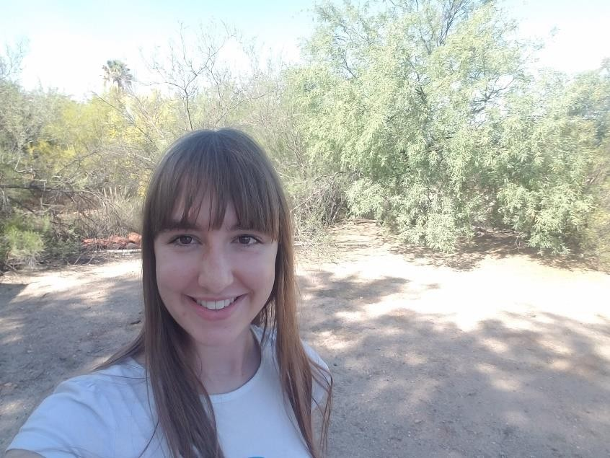

Date: May 3, 2020
Time: 8:46
Habitat type: discovered in garden under oleander plants, released on patch of bare ground with surrounding creosote bush and mesquite shrub near wash in Arizona upland Sonoran desertscrub suburban area
Specific location: ...

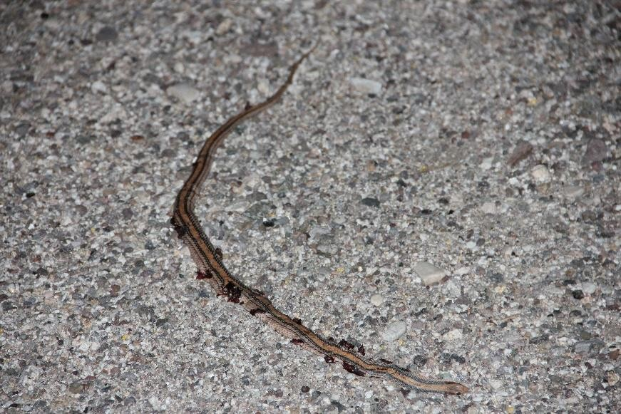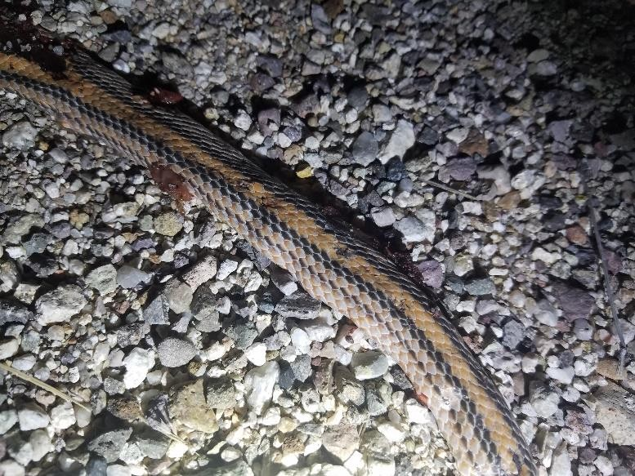
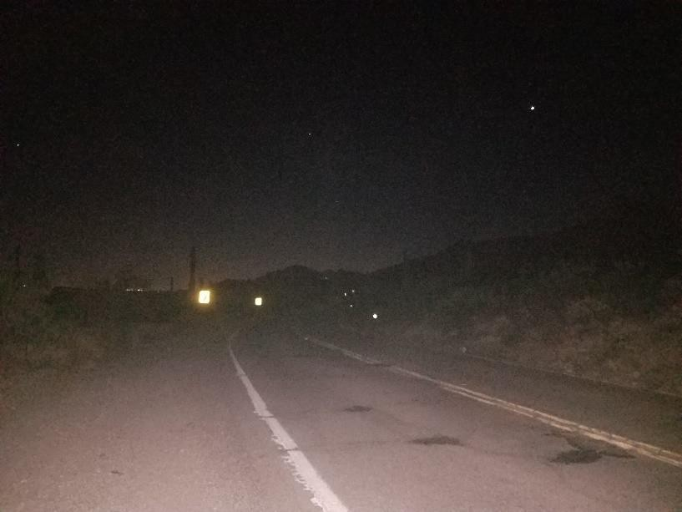
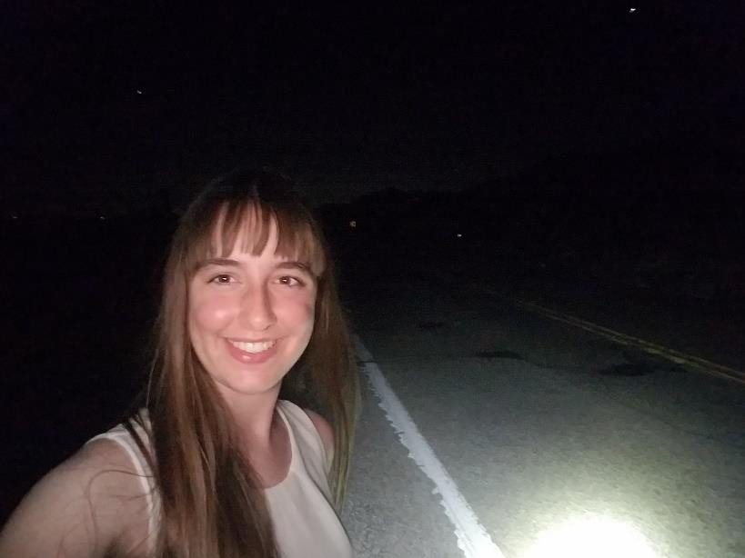

Date: May 4, 2020
Time: 20:26
Habitat type: squashed on road, vicinity is Arizona upland Sonoran desertscrub
Specific location: 32°15.1201’N, 110°40.7264’W, 4.1 km east of intersection of N. Wentworth Rd. and E. Redington Rd.

Squamata (lizards - 8):
9. Sonoran spotted whiptail – Aspidoscelis sonorae
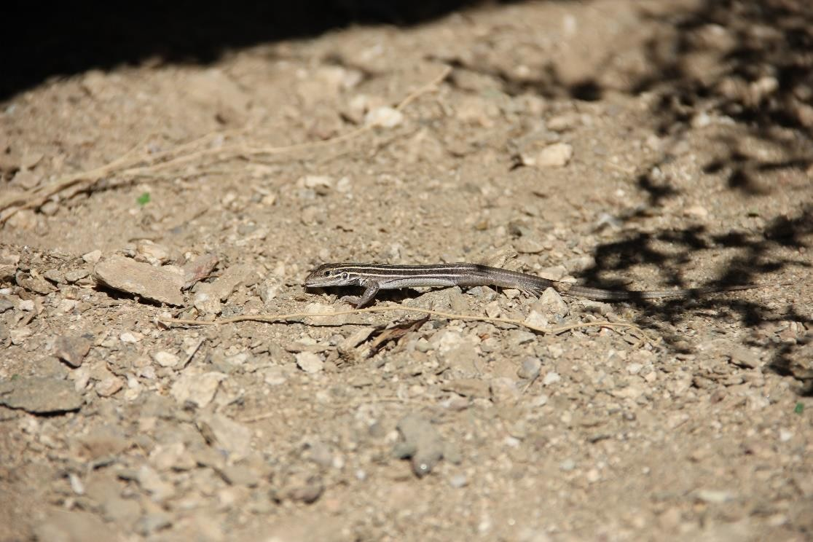

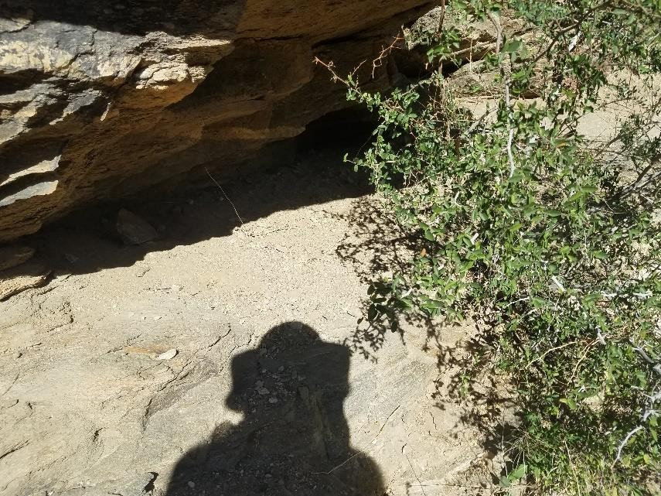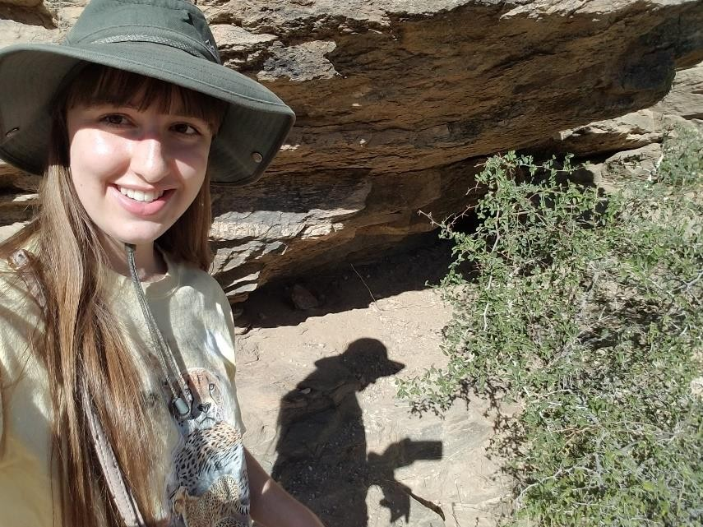

Date: April 18, 2020
Time: 8:37
Habitat type: crawling under desert hackberry bush next to rocky slope in Arizona upland Sonoran desertscrub
Specific location: 32°19.0234’N, 110°48.6640’W, Sabino Canyon, 1.32 km from visitor center following N. Sabino Canyon Rd., 200 m along trail that proceeds SE of paved road

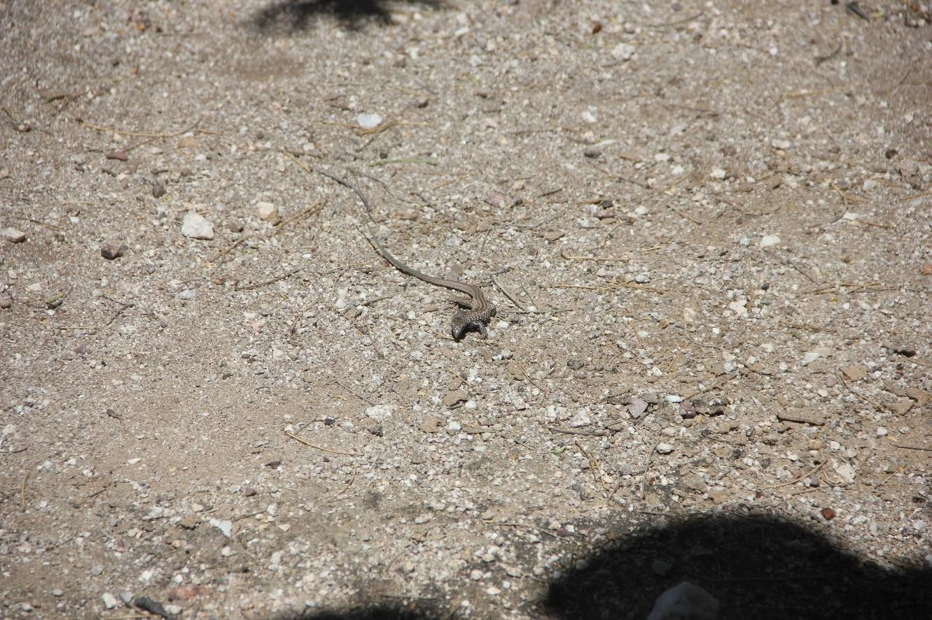
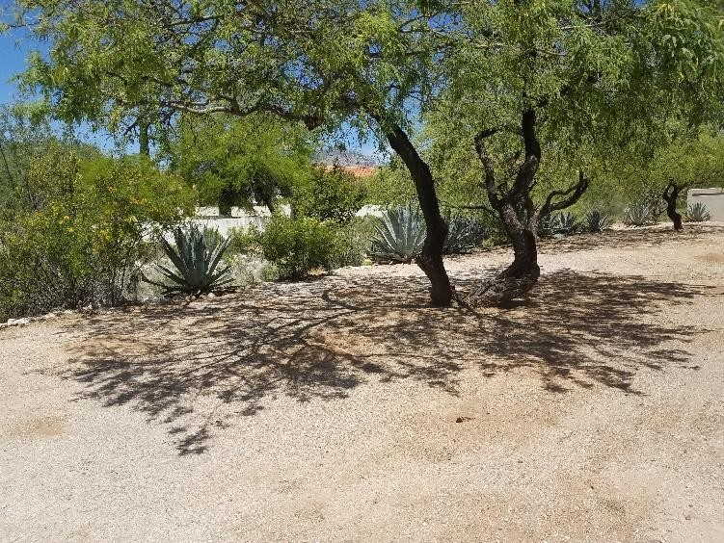
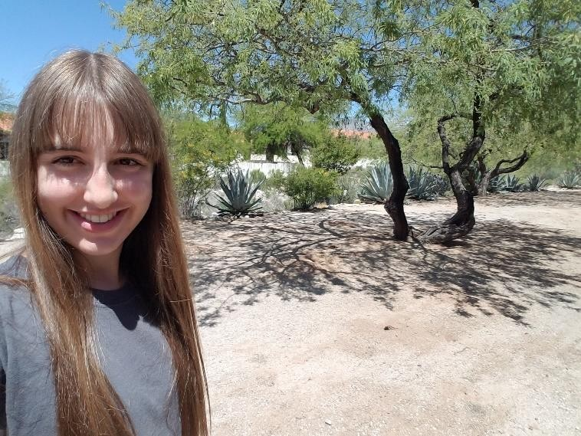

Date: April 21, 2020
Time: 12:02
Habitat type: crawling over bare ground under tall mesquite tree in Arizona upland Sonoran desertscrub suburban area
Specific location: ...

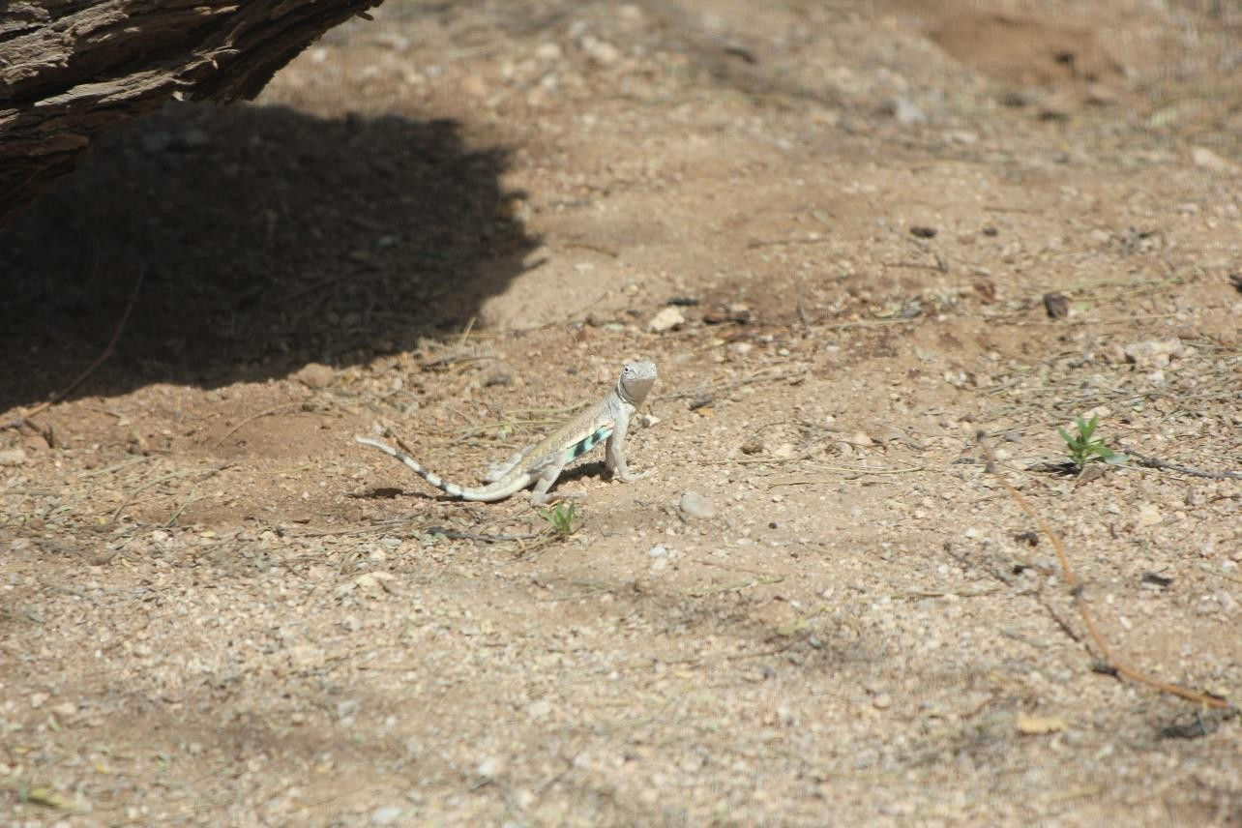
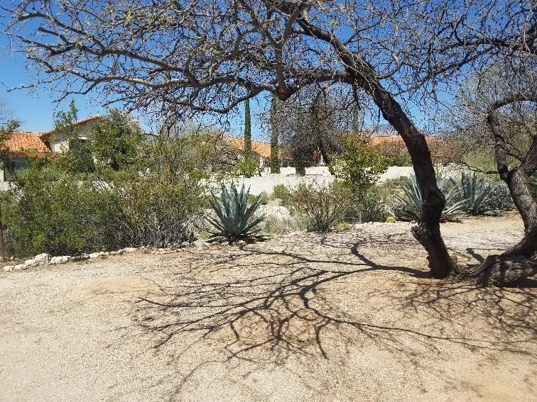
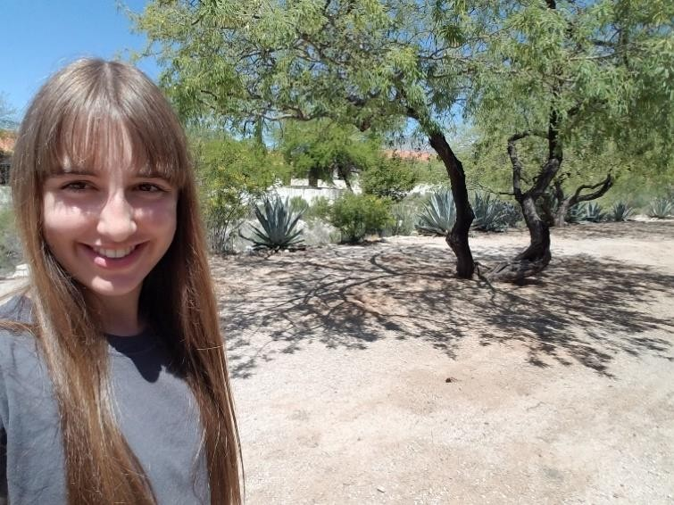

Date: March 30, 2020
Time: 11:46
Habitat type: crawling over bare ground under tall mesquite tree in Arizona upland Sonoran desertscrub suburban area
Specific location: ...

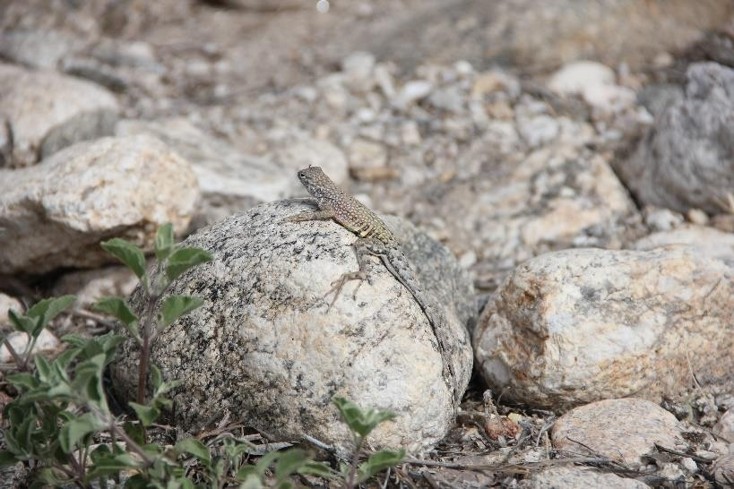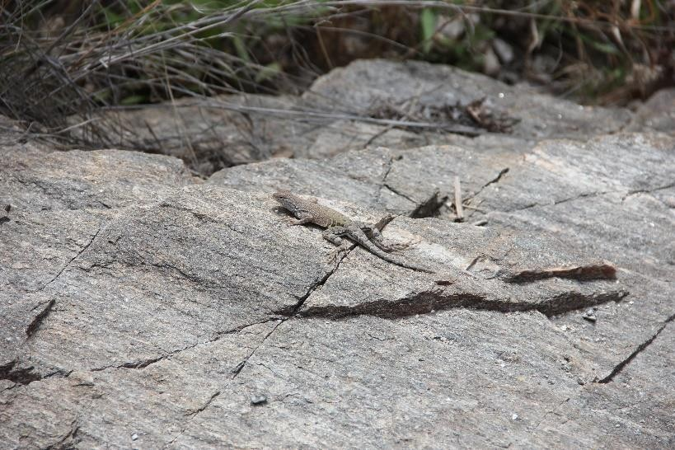
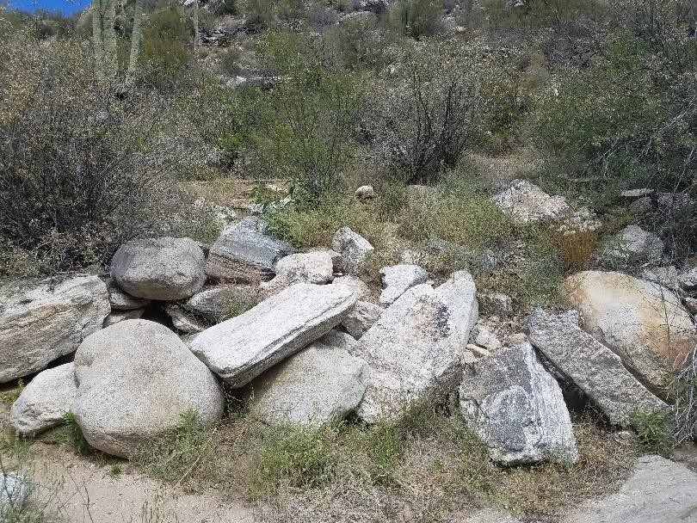
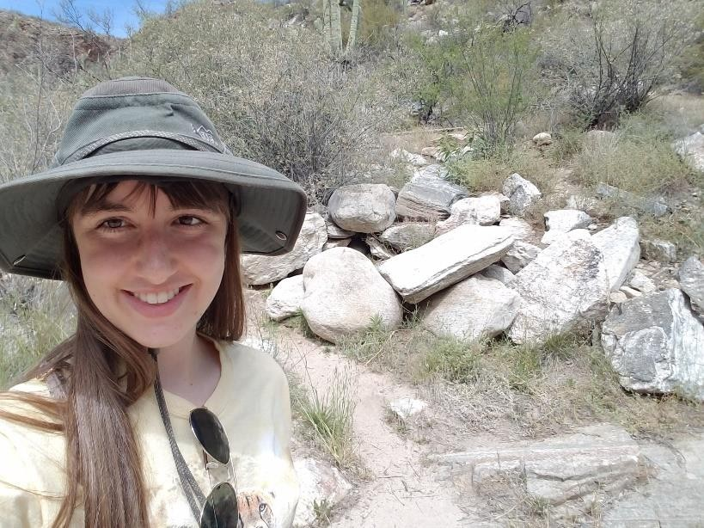

Date: April 18, 2020
Time: 11:05
Habitat type: sitting on rock located 15 m from water’s edge, vicinity is Arizona upland Sonoran desertscrub
Specific location: 32°19.4123’N, 110°48.4756’W, Sabino Canyon, 2 km from visitor center following N. Sabino Canyon Rd., 7 m south of road

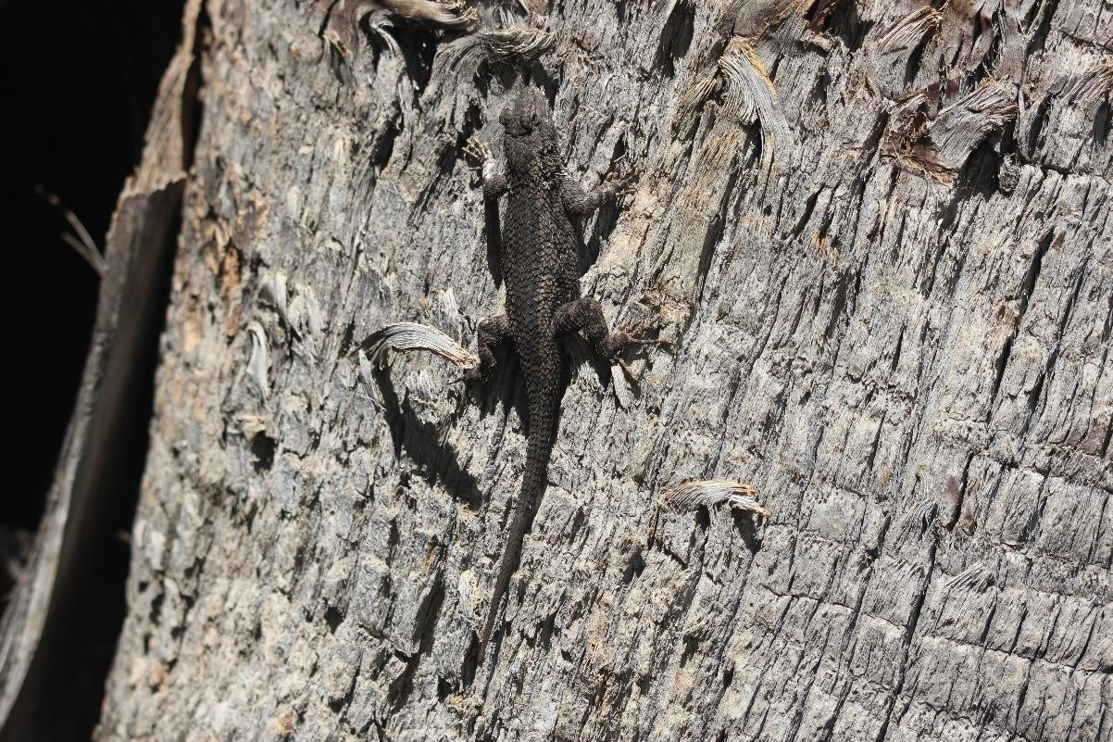

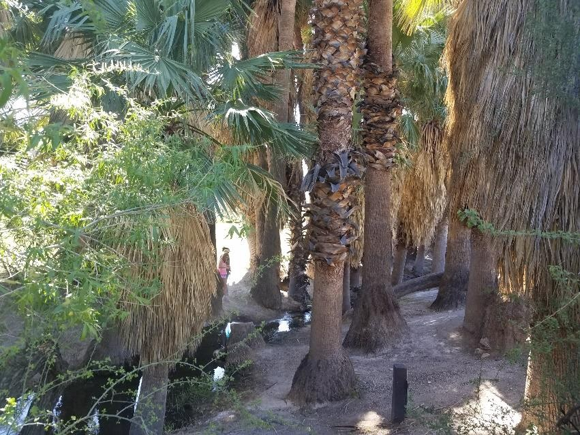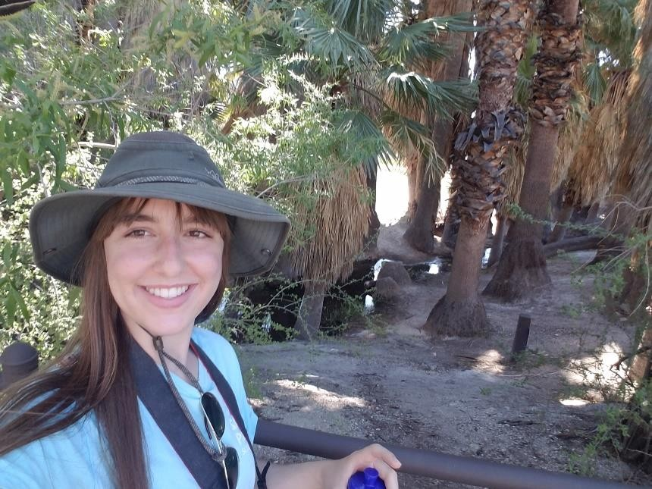
Date: April 1, 2020
Time: 14:20
Habitat type: sitting on palm tree located 5 m from water’s edge, immediate vicinity is riparian and surrounding vicinity is Arizona upland Sonoran desertscrub
Specific location: 32°16.8345’N, 110°43.7778’W, Agua Caliente Park, 142 m following Agua Caliente Park Rd. from intersection of E. Roger Rd. and Agua Caliente Park Rd., 36 m north of road

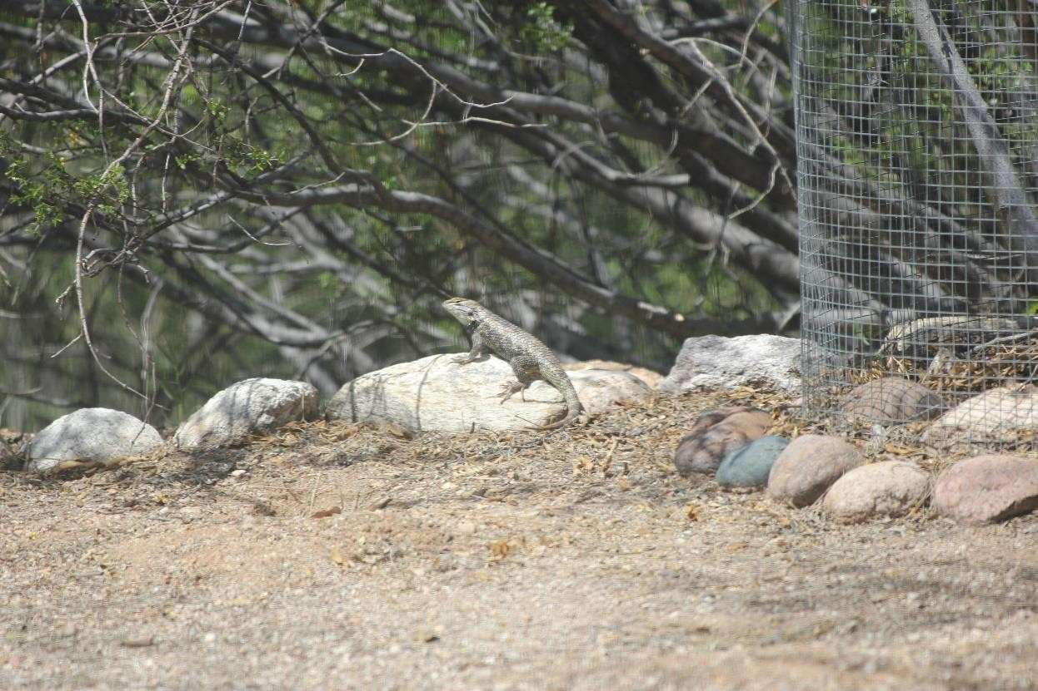
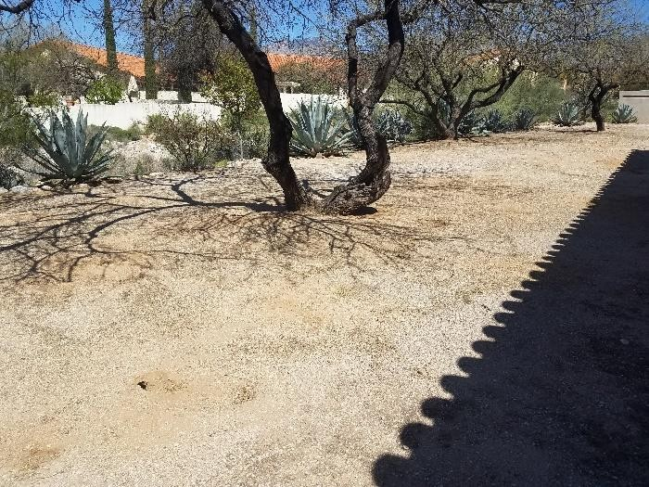
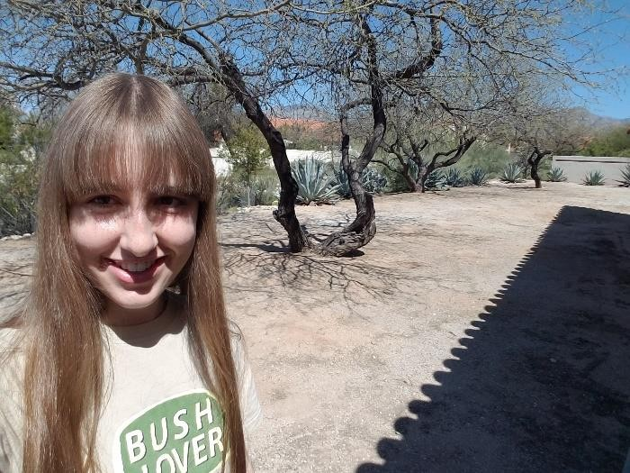
Date: March 28, 2020
Time: 10:55
Habitat type: basking on rock near tall mesquite tree in Arizona upland Sonoran desertscrub suburban area
Specific location: ...

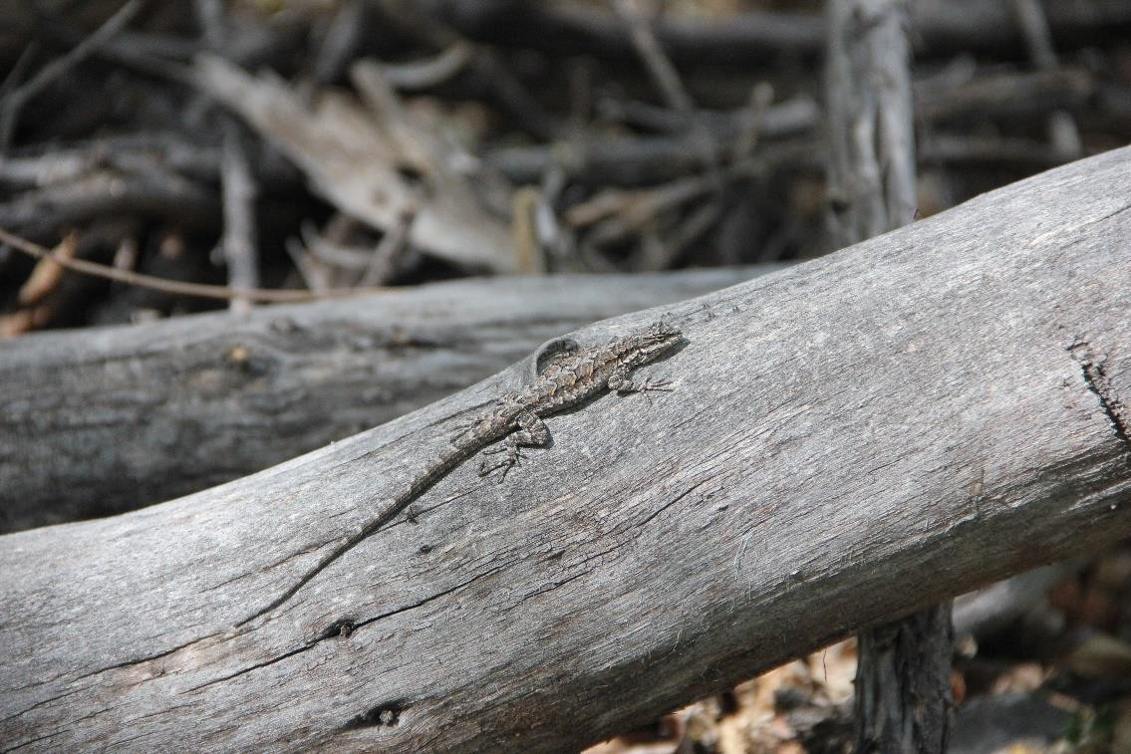
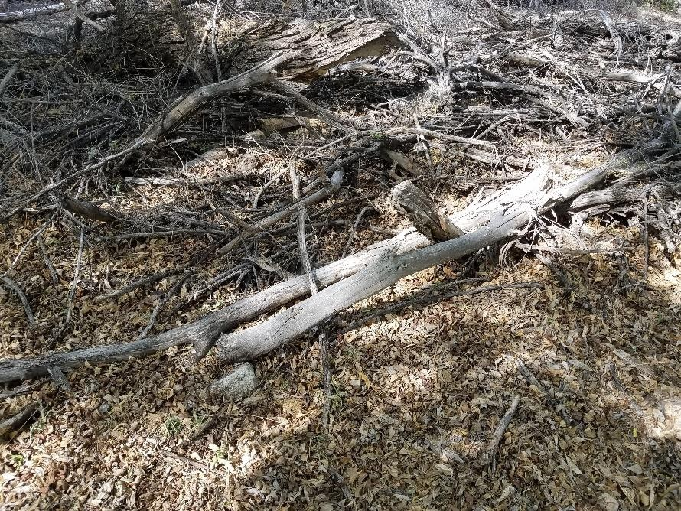
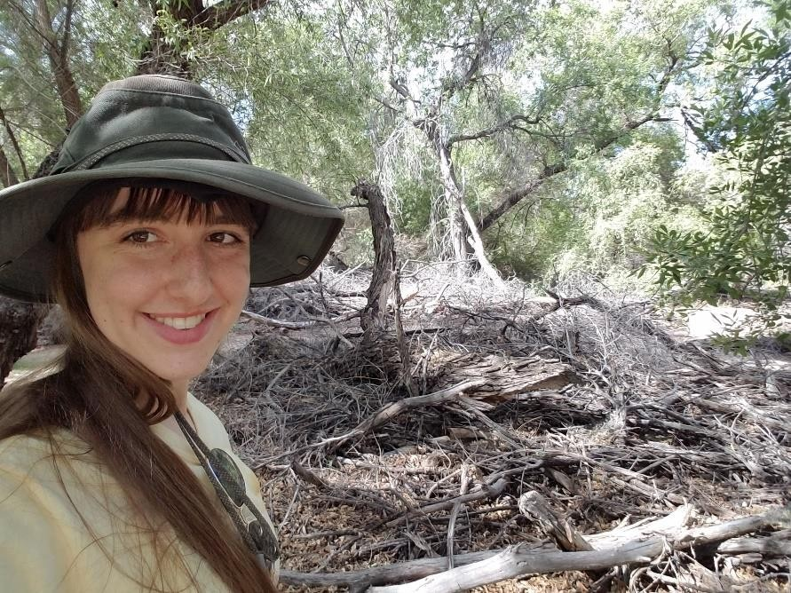

Date: April 18, 2020
Time: 9:22
Habitat type: basking on fallen branch located 20 m from Sabino Lake in riparian area, immediate vicinity is riparian and surrounding vicinity is Arizona upland Sonoran desertscrub
Specific location: 32°18.9363’N, 110°48.6441’W, Sabino Canyon, 101 m northeast of Sabino Creek Dam

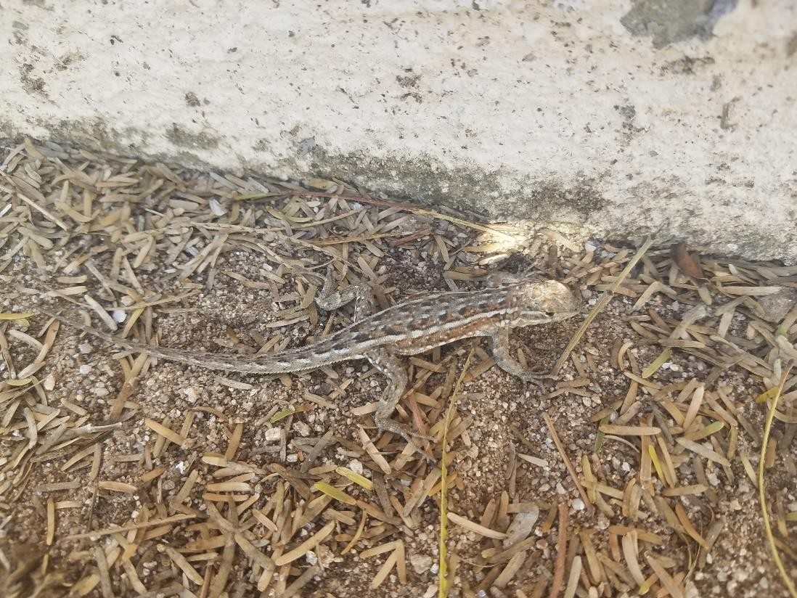
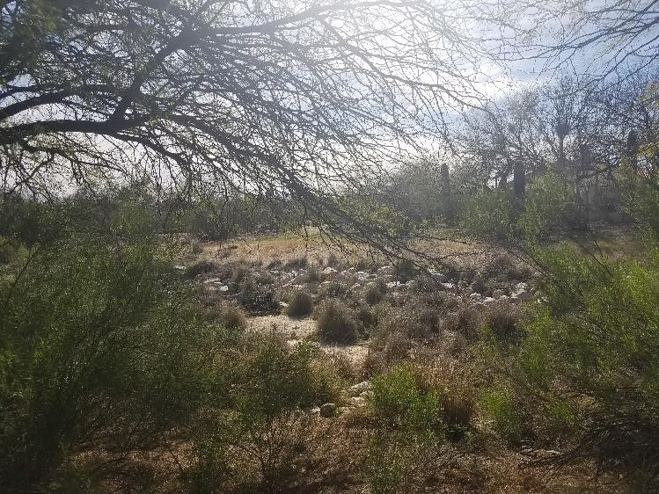
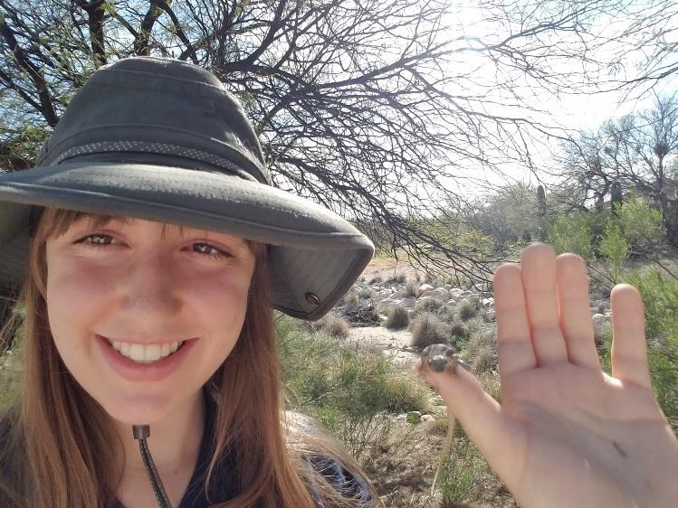

Date: March 24, 2020
Time: 15:41
Habitat type: sitting on ground near creosote bushes and wash, vicinity is Arizona upland Sonoran desertscrub suburban area
Specific location: ...

Introduced (3):
17. American bullfrog – Lithobates catesbeiana
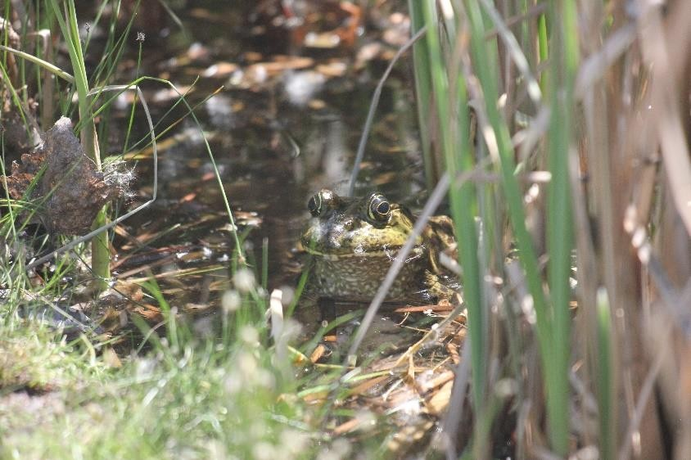
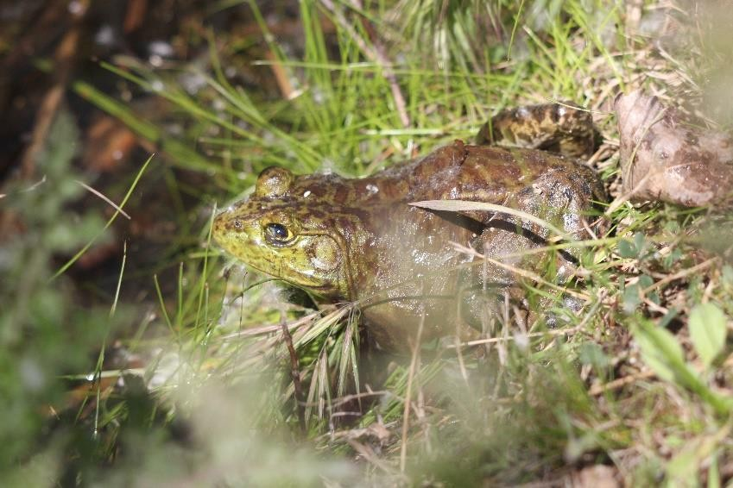
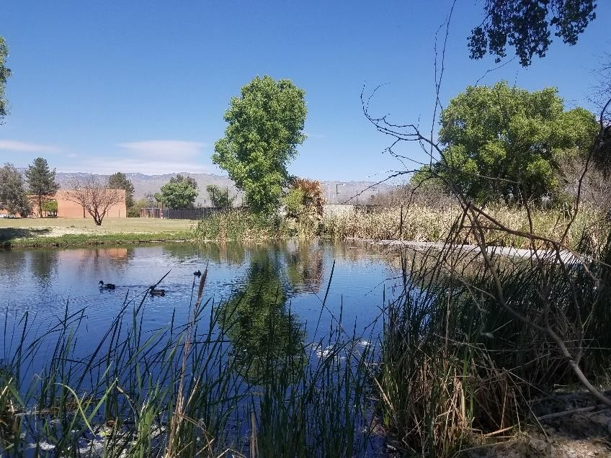
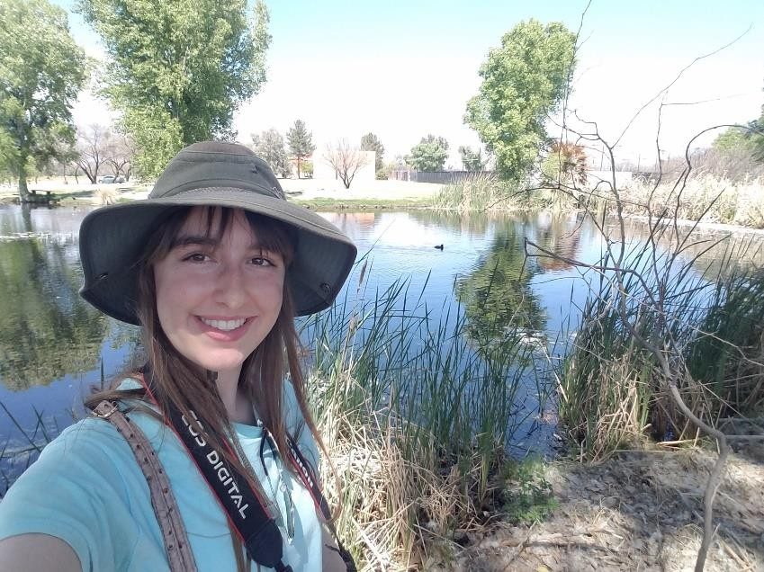

Date: April 1, 2020
Time: 13:04
Habitat type: sitting in water at edge of pond, surrounded by reeds, surrounding vicinity is Arizona upland Sonoran desertscrub
Specific location: 32°14.4149’N, 110°46.7322’W, La Mariposa Resort, 294 m south along E. Corte Vista La Mariposa after it becomes N. Houghton Rd., 36 m east of road

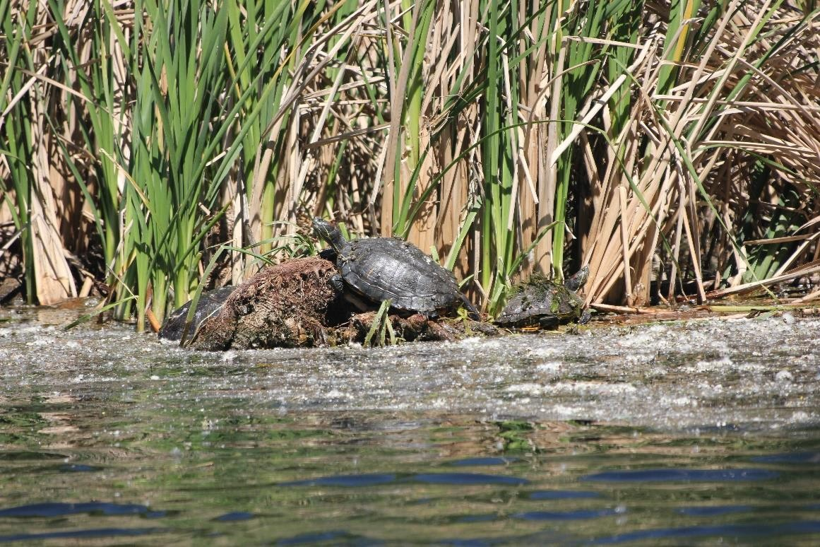
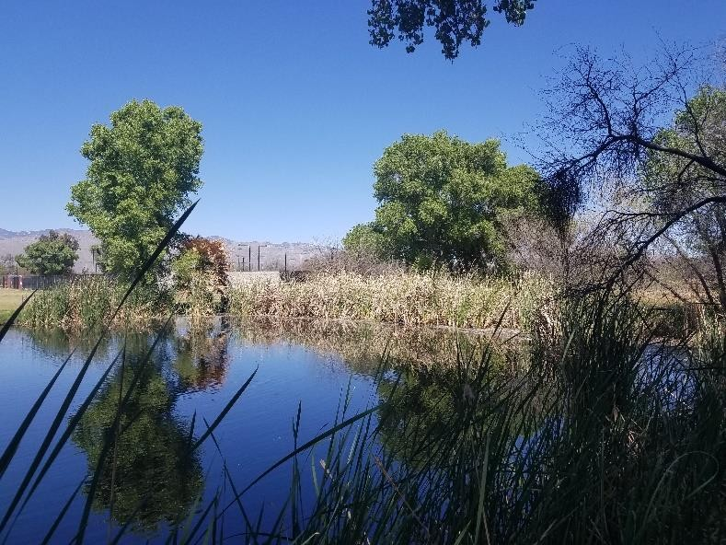
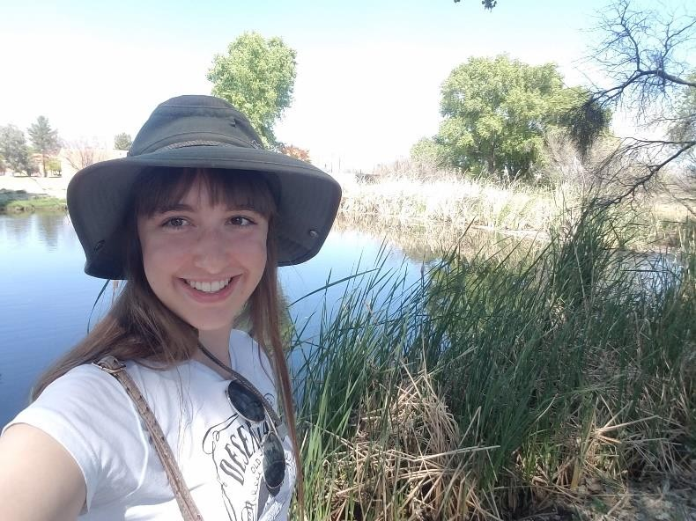

Date: April 4, 2020
Time: 13:38
Habitat type: sitting at water’s edge in pond, surrounded by reeds, surrounding vicinity is Arizona upland Sonoran desertscrub
Specific location: 32°14.4149’N, 110°46.7322’W, La Mariposa Resort, 294 m south along E. Corte Vista La Mariposa after it becomes N. Houghton Rd., 36 m east of road

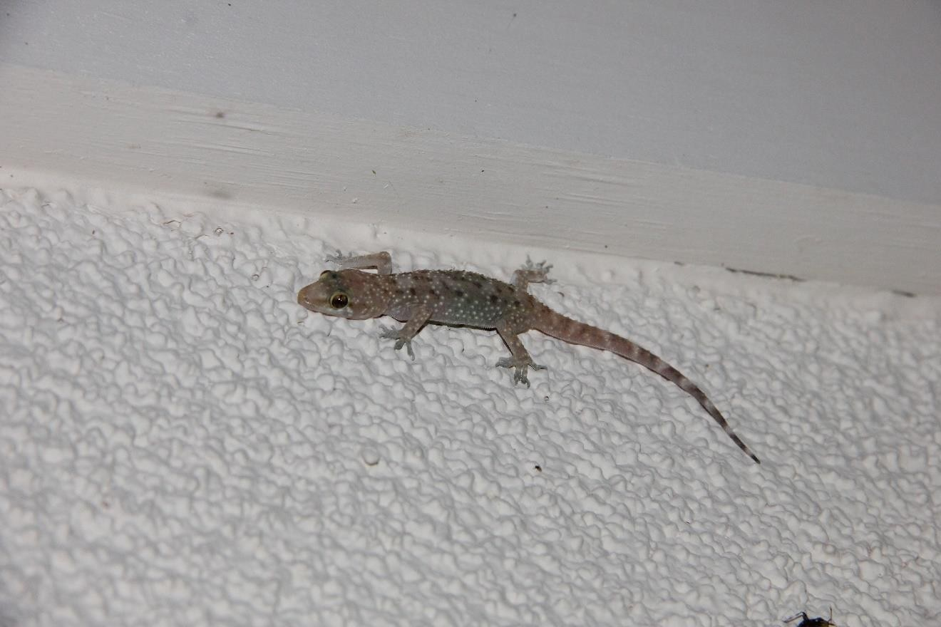
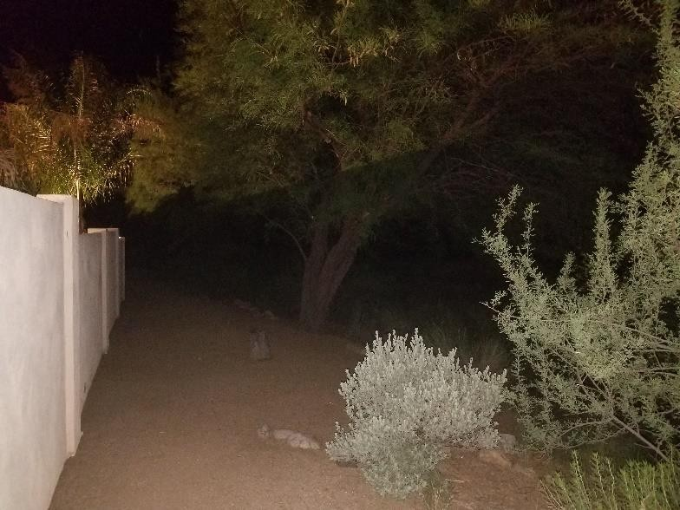
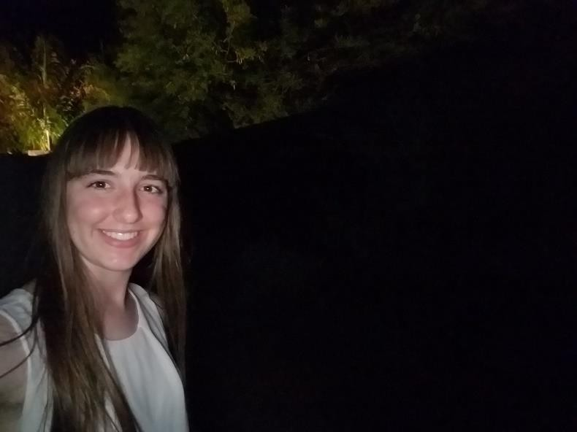
Date: May 3, 2020
Time: 22:00
Habitat type: foraging for invertebrates on wall, vicinity is Arizona upland Sonoran desertscrub suburban area
Specific location: ...

