Daily Activity Patterns of Giant Pandas (Ailuropoda melanoleuca) and the Implications for
Conservation

Study Organism:

The giant panda (Ailuropoda melanoleuca) is a highly charismatic species toward which human beings have developed a strong inclination to conserve and study. Giant pandas belong to the bear family Ursidae. They are a distinguishable black and white bear with black raccoon-like markings around the eyes and are approximately the size of the American black bear (Ursus americanus). Giant pandas are a solitary species with some range overlap between the different sexes. They are endemic to China and their primary habitat is in the cool, wet bamboo forests of six mountain ranges varying from elevations of 1,500 to 3,000 meters (Zhang et al. 2015).

Though the giant panda is included under the order Carnivora, 99% of its diet consists of bamboo (Swaisgood et al. 2003). Bamboo has low nutritional value and the digestive system of giant pandas is unable to absorb sufficient amounts of protein from the food source; therefore, individuals spend 55% of their time eating (Swaisgood et al. 2003). Information regarding the species’ activity patterns has been limited until recently (Zhang et al. 2015). According to Zhang et al. (2015), they display variability in energy allocation and activity by season, consistent with the optimal foraging theory, and also exhibit a unique daily activity pattern. The authors note it was initially believed that wild giant pandas have a pattern similar to that of diurnal sun bears or crepuscular grizzly bears, though found they demonstrate activity patterns resembling that of large ungulate species due to similar diets. These patterns consist of three daily activity peaks that occur in the morning, afternoon, and at midnight (Zhang et al. 2015). This illustrates the metabolic demands the animal must meet (Swaisgood et al. 2003) in addition to the need for intense habitat conservation to meet those demands.

Habitat loss and fragmentation are the leading threats to giant pandas (Yang et al. 2018). Loss of habitat has resulted in several small, genetically isolated populations and has limited the accessibility to bamboo (Yang et al. 2018). The species was listed as endangered from 1990 to
2016 with little knowledge of population statistics prior to the initial listing. Since then, humans have taken great strides to develop conservation plans, create habitat corridors, restore forests, and designate protected land to conserve the species (Wang & Liu, 2016). Captive breeding has also been underway. As a result of these conservation efforts, reassessment of the population in
2014 found that numbers were steadily increasing and consisted of over 1,800 total individuals. Therefore, they meet the criteria to be updated to ‘vulnerable’ status on the IUCN Red List (Swaisgood et al. 2016).

Do giant pandas show distinct differences in behavior at the three times of day they are most active and if so, how can zoos utilize this information to improve conditions in captivity and increase breeding success?

Methods:

Observations of giant pandas were taken by using 24/7 livestream cameras at the Smithsonian’s National Zoo and Conservation Biology Institute located in Washington D.C. The exhibit was composed of two enclosures, one indoor and one outdoor. The methods employed were continuous focal sampling. This consisted of watching two individual pandas for separate periods of time and recording the durations of different behaviors performed. The observation times were designated to three main categories: morning (8:00 to 10:00), afternoon (13:00 to
16:00), and midnight (23:00 to 1:00).

The two animals observed were a 20-year-old female named Mei Xiang, and a 21-year-old male named Tian Tian. In total, 20 observation hours were taken: 10 hours for the female and 10 hours for the male. Each of the five group members was allocated four hours of observation time: two hours for the female and two hours for the male. Three group members had one hour observation intervals (one hour per day, observing one panda per day). One of these members did their one hour intervals during the morning category, another member did their one hour intervals during the afternoon category, and a third member did their one hour intervals during the midnight category. The other two members took their four hours of observation time in 40 minute
intervals. Both of these members did a 40 minute interval per category (morning, afternoon, and midnight) each day, observing one panda per day. Hence, these members did two 40 minute intervals in the morning category, two 40 minute intervals in the afternoon category, and two 40 minute intervals in the midnight category. Each of the five members logged the duration times for each observed behavior into a shared spreadsheet. When the entire 20 hours’ worth of observations were taken, the behavior duration times were totalled for each time category. Finally these were compiled into three pie charts, one per category (morning, afternoon, and midnight).

Results:

Ethogram:

Eating Putting bamboo in mouth, chewing, and swallowing. Frequently done while sitting.
Drinking Putting liquid in mouth and swallowing it. Rolling Moving by turning over repeatedly on an axis.
Sleeping Lying down but no longer functioning at full cognitive capacity. Scratching The use of an appendage to relieve an itch.
Climbing The activity of ascending trees or other structures.

Solitary Play When the individual is alone and maintains focus on interacting with an object.

Wandering Using all four legs to walk at a slow pace.

Sitting In a seated position for a continuous amount of time.
Standing on Hind
Legs Against Wall
When an individual is upright with its back legs extending and bearing weight against a wall.

Lying Down In a position where the legs are no longer supporting the body.

Standing When an individual is upright with four legs extended and bearing weight.

Stretching Straightening or extending a part of the body to its full length to tighten muscles.

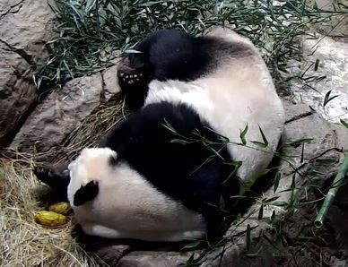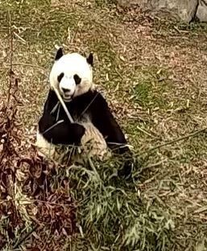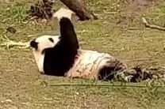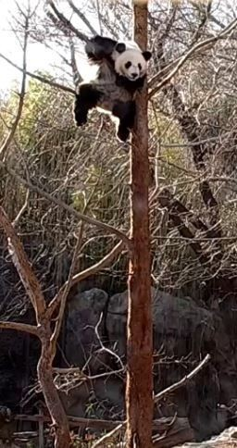

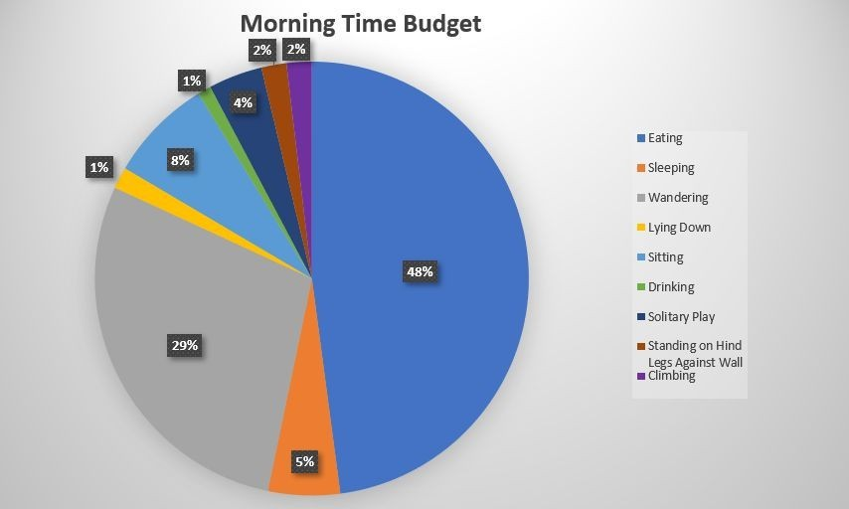

Figure 1: Morning time budget (8:00 to 10:00)
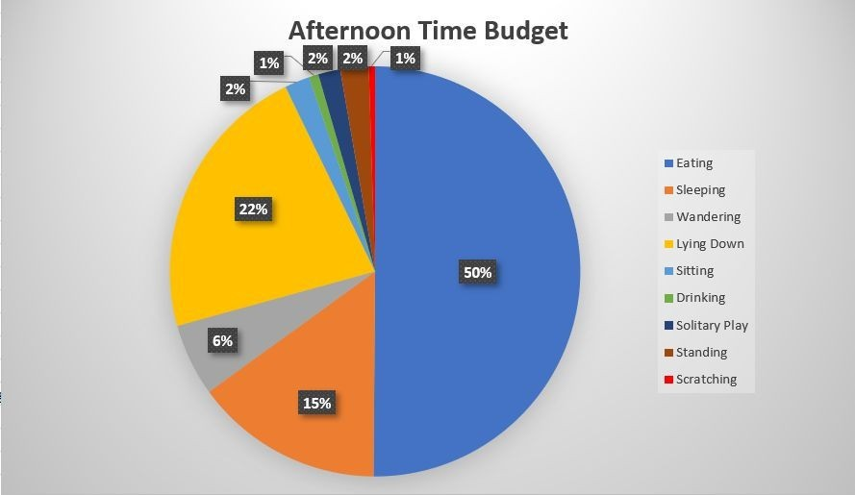

Figure 2: Afternoon time budget (13:00 to 16:00)
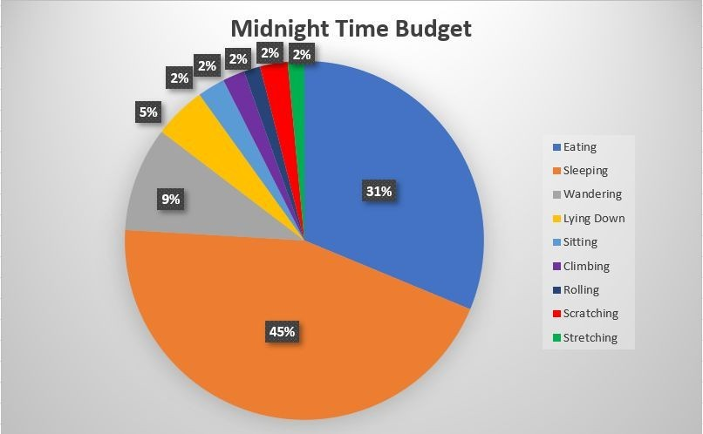

Figure 3: Midnight time budget (23:00 to 1:00)

Discussion & Conclusions:

The results suggest that there are distinct differences in giant panda behavior at the three times of day they are most active. While eating composes approximately half in both morning and afternoon periods (Figs. 1 and 2), it constitutes a third at midnight (Fig. 3). Sleeping dominates half the pandas’ activity patterns at midnight and a third in the afternoon when combined with lying down. Lastly, wandering is also prominent in the morning at over a fifth and at midnight at a tenth. Nonetheless, there were also some discrepancies that occurred during the observation
periods. Occasionally observers reported the pandas wandering off camera, sometimes at close to
1:30 minutes at a time. This hindered observation and potentially slightly skewed the data given that 20 hours of observation total is a small sample. Some members also had to split up their time intervals in an odd fashion on certain days due to scheduling conflicts (i.e. observing for 1.5
hours one day and 30 minutes the next), but still met the requirements by adjusting their observation times accordingly the following day.

According to Zhang et al. (2015), the reported differences in behaviors as well as behavioral peaks have important implications for giant panda conservation given that the species has a tight energy budget from feeding on low quality forage. Thus, it must allocate its time efficiently and have access to food on a regular basis. The authors also note increased activity patterns allow for
higher rates of metabolism, which may explain why eating composes a majority of all three time budgets. Another study on captive panda behavior reports approximately equal amounts of time spent eating and wandering in captivity, though “stereotyped” activities such as pacing were less in larger enclosures with increased habitat heterogeneity (Liu et al. 2003). Pacing and wandering might also be decreased by providing the animals with two types of enclosures (Owen et al.
2005), particularly in the morning when this behavior is at its peak. These could differ in microclimate, proximity to visitors, and enrichment activities that can reduce the amount of
stress and therefrom time spent wandering by half (Swaisgood & Shepherdson, 2006). Reduction of loud, chronic noise might also improve panda wellbeing (Owen et al. 2004), particularly in the afternoon when resting behavior is prominent. Owen et al. (2004) however also note that pandas exposed to noise in zoos continue to exhibit normal behaviors, including eating and resting, and that it might have a more serious effect on wild pandas that are unaccustomed to humans. The authors point out it may affect reproduction for captive breeding efforts as well, though stress as indicated from wandering and a lack of enrichment items has a more significant effect. Thus, providing giant pandas with opportunities to reduce their stress levels largely depends on which particular behaviors they exhibit at the three times of day they are most active. This in turn will likely improve captive breeding success and aid conservationists in protecting one of the world’s most iconic species.

Literature Cited:

Liu, D., Wang, Z., Tian, Hong., Yu, C., Zhang, G., Wei, R., & Zhang, H. (2003). Behavior of giant pandas (Ailuropoda melanoleuca) in captive conditions: gender differences and enclosure effects. Zoo Biology, 22, 77-82.

Owen, M. A., Swaisgood, R. R., Czekala, N. M., & Lindburg, D. G. (2005). Enclosure choice and well-being in giant pandas: is it all about control? Zoo Biology, 24, 475-481.

Owen, M. A., Swaisgood, R. R., Czekala, N. M., Steinman, K., & Lindburg, D. G. (2004).
Monitoring stress in captive giant pandas (Ailuropoda melanoleuca): behavioral and hormonal responses to ambient noise. Zoo Biology, 23, 147-164.

Smithsonian National Zoo and Conservation Biology Institute. (2019). Giant Panda Livestream
Camera. Retrieved from: https://nationalzoo.si.edu/webcams/panda-cam

Swaisgood, R., & Shepherdson, D. (2006). Environmental enrichment as a strategy for mitigating stereotypies in zoo animals: a literature review and analysis. Stereotypic Animal Behaviour, 9, 255-285.
Swaisgood, R., Wang, D., & Wei, F. (2016). Ailuropoda melanoleuca. The IUCN Red List of
Threatened Species 2016. Downloaded on 27 April 2019.

Swaisgood, R., Zhou, X., Zhang, G., Lindberg, D. G., & Zhang, H. (2003). Application of behavioral knowledge to conservation of the giant panda. International Journal of Comparative Psychology, 16, 65-84.

Wang, F., & Liu, J. (2016). Conservation planning beyond giant pandas: the need for an innovative telecoupling framework. Science China Life Sciences, 60, 551-554.

Yang, Z., Gu, X., Nie, Y., Huang, F., Huang, Y., Dai, Q., Yang, Y., Zhou, X., Zhang, H., Yang, X., & Wei, F. (2018). Reintroduction of the giant panda into the wild: a good start
suggests a bright future. Biological Conservation, 217, 181-186.

Zhang, J., Hull, V., Huang, J., Zhou, S., Xu, W., Yang, H., McConnell, W. J., Li, R., Liu, D., Huang, Y., Ouyang, Z., Zhang, H., & Liu, J. (2015). Activity patterns of the giant panda (Ailuropoda melanoleuca). Journal of Mammalogy, 96, 1116-1127.

